**ETEA PREPARATION WEB APPLICATION**



**Farman Ullah**

**Department of Computing**

**Abasyn University Peshawar**

**June, 2023**

**ETEA PREPARATION WEB APPLICATION**



Submitted by:

**Farman Ullah**

**AUP-19FL-BSCS-15352**

Supervised by:

**Dr. Mohammad Khan Afridi**

A final year project report submitted in partial fulfillment of the requirement for the award of Bachelor of Science in Computer Science.

**Department of Computing**

**Abasyn University Peshawar**

**June, 2023**

## Project Approval

This is certified that this project report entitled “**ETEA PREPARATION”** is developed and submitted by “**Farman Ullah**” registration number “**AUP-19FL-BSCS-15352**”. Meets the required standards for warrant its acceptance by the department of computing, Abasyn University Peshawar in partial fulfilment for the award of Bachelor of Science in Computer Science.

## Approval Committee:

|  |  |  |
| --- | --- | --- |
| **Supervisor** | Name | Dr. Mohammad Khan Afridi |
| Designation | Assistant Professor |
| Institute | Abasyn University, Peshawar |
| Signature |  |

|  |  |  |
| --- | --- | --- |
| **External Examiner** | Name |  |
| Designation |  |
| Institute |  |
| Signature |  |

|  |  |  |
| --- | --- | --- |
| **Internal Examiner** | Name |  |
| Designation |  |
| Institute |  |
| Signature |  |

**Head of Department:**

|  |  |
| --- | --- |
| Name | Dr. Abdus Salam |
| Signature |  |

**DECLARATION OF ORIGINALITY**

I hereby declare that this project report entitles as “**ETEA PREPARATION**” is based on my original work except for citations and quotations which have been duly acknowledged. I also declare that it has not been previously and concurrently submitted for any other degree or award at Abasyn University Peshawar or any other institutions. I hereby undertake that if any part of this work is proved to be copied or found to be a part of some other work, the Abasyn University Peshawar reserves the right to withdraw/revoke my degree.

________________

**Farman Ullah**

I dedicated my work to my honorable teachers and parent who is always become the key of Success in my life I will always remember my teachers in very point of life. I am very thankful to all of them at last especially thanks to almighty Allah who makes me able to do this great job.

**ACKNOWLEDGEMENTS**

I would like to thank everyone who had contributed to the successful completion of this project. I would like to express my gratitude to my project supervisor, **Dr. Mohammad Khan Afridi** for his invaluable advice, guidance and his enormous patience throughout the development and completion of this project. In addition, I would also like to express my gratitude to my loving parent and friends who had helped and given me encouragement

**ABSTRACT**

ETEA Preparation web application provides a comprehensive platform for students, academies, and teachers. It features modules such as academy registration, user registration with academies, chat functionality, a Q&A module, online classes, online exams, membership options, lecture posting, and detailed reports for academies. Academies can register on the platform, enabling them to showcase their expertise. Students can then register with their preferred academies, facilitating personalized learning experiences. The chat module enables real-time communication, while the Q&A module allows students to seek expert guidance. Online classes and exams provide convenient access to educational content and practice tests. Membership options offer premium features and personalized resources. Lectures can be posted for students' reference. Detailed reports assist academies in monitoring student and teacher performance. Our web application aims to enhance ETEA preparation by providing a comprehensive and interactive learning environment for all stakeholders involved.

**TABLE OF CONTENTS**

**APPROVAL FOR SUBMISSION .........................................................................i**

**DECLARATION OF ORIGINALITY ……….....................................................ii**

**DEDICATION .......................................................................................................iii**

**ACKNOWLEDGMENTS .....................................................................................iv**

**ABSTRACT .............................................................................................................v**

**TABLE OF CONTENTS .......................................................................................vi**

**LIST OF TABLES.................................................................................................xii**

**LIST OF FIGURES .............................................................................................xiii**

**CHAPTER TITLE PAGE**

1. **INTRODUCTION**
   1. Background Information …………………………………………………….. 1
   2. Aims & Objectives…………………………………………………………... 2
   3. How ETEA Preparation Website Work ………………………………….….. 2
      1. Super Admin ………………………………………....................................... 3
      2. Academy Admin ……………………………………………………………. 3
      3. Teachers ………………………………………….…………………………. 3
      4. Students ……………………………………………………………………... 4
   4. Proposed Modules in ETEA Preparation System …………………………… 4
   5. Chapter 2 …………………………………………………………………….. 4
   6. Chapter 3 …………………………………………………………………….. 4
   7. Chapter 4 …………………………………………………………………….. 5
   8. Chapter 5 …………………………………………………………………….. 5
   9. Chapter 6 …………………………………………………………………….. 5

1.10 Chapter 7 …………………………………………………………………….. 6

* 1. Chapter 8....………………………………………………………………….. 6

1. **RELATED WORK**
   1. Introduction………………………………………………………………....... 7
   2. Khan Academy……………………………………………………………….. 7
   3. Quizlet………………………………………………………………............... 8
   4. Coursera………………………………………………………………............ 8
   5. BYJU’S………………………………………………………………............. 9
2. **REQUIREMENT ANALYSIS & SPECIFICATION**
   1. Introduction ………………………………………………………………… 11
   2. Purpose of the system ……………………….……………………………….11
   3. Scope of the system …..…………………….………………………………..11
   4. Functional Requirements …………………………………………………....12
      1. Academies registration ……………………………………………………...12
      2. Registration with Academies ……………………………………………….12
      3. Chat ………………………………………………………………………....12
      4. Q&A ………..……………………………………………………………… 12
      5. Online Classes ………………………………………………………………13
      6. Online Exams ……………………………………………………………….13
      7. Membership ………………………………………………………………...13
      8. Lectures posting …………………………………………………………….13
      9. Reports ……………………………………………………………………...13
   5. Non Function Requirements ………………………………………………...13
      1. Usability ……………………………………………….................................13
      2. Reliability ……………………………………………….............................. 13
      3. Performance ………………………………………………...........................13
      4. Supportability ………………………………………………........................ 14
      5. Implementation ………………………………………………..................... 14
      6. Interface ………………………………………………................................ 14
   6. Current system …………………………………………………………….. 14
3. **SYSTEM DESIGN**
   1. System Models …………………………………………………………….. 16
   2. Scenarios ……………………………………………………………….….. 16
   3. Use Case model ……………...…………………………………………....... 17
      1. Admin Use Case Model ……………………………………………………. 18
      2. Academy Admin Use Case Model …………………………………………. 19
      3. Teacher Use Case Model …………………………………………………... 19
      4. Student Use Case Model …………………………………………………... 20
   4. Level of Data Flow Diagram ……………………………………………… 22
      1. Level 0 DFD ………………………………………………………………. 22
      2. Level 1 DFD ………………………………………………………………. 22
      3. Level 2 DFD ……………………………………………………………….. 23
4. **IMPLEMENTATION**
   1. Primary Programming Language ………....................................................... 26
      1. Python …………........................................................................................... 26
      2. Django …………………….…………......................................................... 26
      3. Django Rest Framework ……………………………………....................... 26
      4. HTML ……………………………………………………………………... 27
      5. CSS ………………………………………………………………………... 27
      6. Bootstrap …………………………………………………………………... 27
      7. JavaScript ………………………………………………………………….. 27
      8. React ………………………………………………………………………. 27
   2. Integrated Development Environments (IDEs) …………………………….. 28
      1. Visual Studio Code ……………………………………………………….... 28
   3. Database Management System …………………………………………….. 29
      1. MYSQL …………………………………………………………………… 29
   4. Tools for Software Testing ………………………………………………… 30
      1. Postman ……………………………………………………………………. 31
   5. Tools for Project Management and Communication ………………………... 32
      1. Notion ……………………………………………………………………... 32
      2. Slack ……………………………………………………………………….. 32
   6. Version Control System …………………………………………………… 33
      1. Git …………………………………………………………………………. 33
   7. User interface ………………………………...…………………………… 33
      1. Home Page ………………………………………………………………… 33
      2. About Us …………………………………………………………………... 34
      3. Contact Us …………………………………………………………………. 35
      4. Academies …………………………………………………………………. 35
      5. Login ………………………………………………………………………. 36
      6. Admin Dashboard ………………………………………………………..... 36
      7. Academies …………………………………………………………………. 37
      8. Comments …………………………………………………………………. 38
      9. Academy Dashboard ………………………………………………………. 39
      10. Profile…………………………...………………………………………… 39
      11. Edit Profile....……………………………………………………………… 40
      12. Change Password …………...…………………………………………….. 40
      13. List of Meetings ………..…………………………………………………. 41
      14. Teachers ……………………………………………...…………………… 41
      15. List of Subjects...………………………………………………………….. 42
      16. Problems …...……………………………………………………………... 43
      17. Teacher and Student Dashboard ……..…………………………………… 43
      18. Classes ……..……………………………………………………………... 45
      19. Assignment and Quizzes...………………………………………………… 45
      20. Lectures..………………………………………………………………….. 47
      21. Language Translations..……………………………………………………. 49
5. **TEST CASE SPECIFICATION**
   1. Introduction …...………………………………………………………….... 50
   2. Test Plan ……………………………………………………………............ 50
   3. Unit testing ………………………………………………………………... 50
      1. Validation testing …………………………………………………………. 52
      2. Integration testing …………………………………………………………. 55
   4. Test Procedure ……………………………………………………………… 57
      1. Software Component to be Tested ………………………………………… 57
      2. Testing procedure …………………………………………………………. 57
      3. Unit test cases …….……………………………………………………….. 57
6. **Software Deployment**
   1. Introduction ……………………………………………………................... 58
   2. Basic …………………………………………………….............................. 58
   3. Multi-service ……………………………………………………................. 59
   4. Rolling …………………………………………………….......................... 59
   5. Blue Green Deployment …………………………………………………... 59
   6. Canary ……………………………………………………............................60
   7. A/B Testing ……………………………………………………....................60
      1. Monitoring and Continuous Improvement ……………………………….....61
7. **Conclusions and Recommendations**
   1. Goals …………………………………………………….............................. 63
   2. Conclusion ……………………………………………………..................... 63
   3. Recommendation ……………………………………………………........... 64

**References** 65

**LIST OF TABLES**

Table 6.1 Unit Testing 52

Table 6.2 Functional Test Case 1 52

Table 6.3 Functional Test Case 2 53

Table 6.4 Functional Test Case 3 54

Table 6.5 Functional Test Case 4 54

**LIST OF FIGURES**

Figure 4.1 Admin Use Case Model 18

Figure 4.2 Academy Admin Use Case Model 19

Figure 4.3 Teacher Use Case Model 20

Figure 4.4 Student Use Case Model 21

Figure 4.5 Level 0 DFD 22

Figure 4.6 Level 1 DFD 23

Figure 4.7 Level 2 DFD 23

Figure 4.8 Entity Relationship Diagram 24

Figure 4.9 ETEA Preparation System Design 25

Figure 5.1 Visual Studio Code Interface 29

Figure 5.2 MYSQL Interface 30

Figure 5.3 Postman Interface 31

Figure 5.4 Home Page 34

Figure 5.4 About Us 34

Figure 5.5 Contact Us 35

Figure 5.6 Academies 35

Figure 5.7 Login Page 36

Figure 5.9 Admin Dashboard 37

Figure 5.10 List of all Academies 37

Figure 5.11 List of all Comments 38

Figure 5.12 Mail 38

Figure 5.13 Academy Dashboard 39

Figure 5.14 Academy Profile 39

Figure 5.15 Academy Edit Profile 40

Figure 5.16 Change Password 40

Figure 5.17 List of Meetings 41

Figure 5.18 List of Teachers 41

Figure 5.19 List of Students 42

Figure 5.20 Subjects 42

Figure 5.21 Problems 43

Figure 5.22 Teacher Dashboard 44

Figure 5.23 Student Dashboard 44

Figure 5.24 Classes 45

Figure 5.25 Teacher side Assignments 45

Figure 5.26 Teacher side Quizzes 46

Figure 5.27 Student side Assignments 46

Figure 5.28 Student side Quizzes 47

Figure 5.29 List of Documents 47

Figure 5.30 List of Videos 48

Figure 5.31 List of Audios 48

Figure 5.32 Language Translation Modal 48

Figure 6.1 Unit Testing 51

**CHAPTER 1**

**INTRODUCTION**

**1.1 Background Information**

ETEA stands for Educational Testing and Evaluation Agency. It is an autonomous testing agency in Pakistan that conducts entrance examinations for admission into educational institutions at the provincial level, particularly in Khyber Pakhtunkhwa (KPK) province. ETEA conducts tests for various educational programs, including medical and engineering colleges, universities, and other professional institutions. The agency is responsible for developing and administering these tests, evaluating the results, and providing merit-based rankings for admissions. Our platform is designed to provide a comprehensive and interactive learning experience for students, academies, and teachers. Whether you're an academy looking to offer ETEA preparation courses or a student aiming to excel in the exams, our application offers a range of modules to cater to your needs.

Academies can easily register on our platform, allowing them to showcase their expertise and offerings. Students, on the other hand, can register themselves with their preferred academies, enabling personalized learning experiences tailored to their specific goals and needs.

To foster effective communication, we have incorporated a chat module that facilitates real-time interaction between students, academies, and teachers. This feature encourages collaboration, knowledge sharing, and query resolution.

Our Q&A module provides a platform for students to seek expert guidance and clarification on ETEA-related topics. This feature ensures that students have access to accurate information and expert advice throughout their preparation journey.

For enhanced learning convenience, our web application offers online classes where academies and teachers can conduct live or recorded sessions. Students can access these classes from anywhere, at any time, ensuring flexibility and convenience in their learning schedule.

To assess their progress and readiness for the ETEA exams, students can take advantage of our online exam module. This feature provides access to practice tests and mock exams, allowing students to gauge their performance and identify areas for improvement.

We also offer membership options, providing students with access to premium content, personalized learning resources, and additional features that further enhance their preparation journey.

Academies and teachers can leverage our platform to post educational lectures and study materials, enabling students to access and review the content at their own pace.

Furthermore, our reports module empowers academies by providing comprehensive reports on the performance and progress of both teachers and students. This feature enables academies to monitor and evaluate the effectiveness of their teaching methods and make data-driven decisions to optimize learning outcomes.

With a focus on comprehensive learning, effective communication, and continuous evaluation, our web application for ETEA Preparation aims to equip students with the necessary knowledge and skills to succeed in their ETEA exams. Join us and embark on your journey towards academic excellence!

**1.2 Aims & Objectives**

The aims and objectives of the ETEA Preparation project are as follows:

* To eliminate the barriers of physical location and financial constraints for students in accessing quality ETEA preparation resources.
* To enhance the overall learning experience and improve the success rate of students in the ETEA exam.
* Students can attend classes without the need for physical presence.
* There is no requirement for students to stay in hostels or pay hostel fees, further reducing the financial burden.
* Students have the freedom to join multiple academies without the need for in-person meetings.
* Students can save on travel expenses, accommodation, and other costs typically incurred when attending physical classes or academies.

**1.3 How ETEA Preparation Website Work**

There are four steps by which ETEA Preparation website work

* + 1. **Super Admin**

The Super admin can sign up and log in. Once logged in, they can perform the following actions:

* Approve and delete academies.
* View academies' statistics.
* See the number of students, teachers, and academies on the website.
* Access detailed information about academies.
* Send emails to academies.
  + 1. **Academy Admin**

The academy admin can sign up and log in. Once logged in, they can perform the following actions:

* Generate reports for teachers and students.
* Approve teachers and students.
* View statistics of teachers and students.
* Chat with teachers and students.
* Arrange meetings with teachers.
* Add new books.
  + 1. **Teachers**

Teachers can sign up and log in. After logging in, they can perform the following actions:

* Arrange online exams for students.
* Chat with students.
* Arrange online classes for students.
* Post recorded videos for future student study.
* Attend academy meetings.
* Answer questions in the Q&A module.
  + 1. **Students**

Students can sign up and log in. After logging in, they can perform the following actions:

* Attend online exams arranged by teachers.
* Chat with assigned teachers.
* Attend online classes arranged by teachers.
* Watch and download recorded videos uploaded by teachers.
* Answer questions in the Q&A module.
  1. **Proposed Modules in ETEA Preparation System**

ETEA Preparation system consist the following modules:

* Academies registration
* Registration with Academies
* Chat
* Q&A
* Online Classes
* Online Exams
* Lectures posting
* Reports
  1. **Chapter 2**

In this chapter, we will critically review the relevant literature in the student's research area. The goal is to examine and comment on existing works, rather than simply compiling them. Integrating ideas, information, data, and arguments coherently is crucial for success in this process.

Typically, reviewing a few key works and briefly mentioning others is sufficient. The literature review should showcase the diversity of perspectives among authors and establish how the student's research aligns within this context.

* 1. **Chapter 3**

In this chapter, we explore the system's functional and nonfunctional requirements, serving as a contractual basis between the customer and the developer. We provide an introduction, highlighting the system's purpose, scope, and objectives, followed by a discussion of the current system or tasks being performed. We then outline the high-level functionality and cover nonfunctional aspects such as usability, reliability, performance, supportability, implementation, and interface. This chapter facilitates effective communication and collaboration by defining the necessary guidelines for system development.

* 1. **Chapter 4**

In this chapter, we will study the system design, which encompasses various components such as scenarios, use case model, object model, dynamic model, and user interface. It provides a detailed functional specification, including mock-ups illustrating the system's user interface and navigational paths. The object model and dynamic model sections are developed during the analysis activity. By examining this chapter, we gain a comprehensive understanding of the system's design, ensuring a well-defined and visually represented system architecture.

* 1. **Chapter 5**

In this chapter, we will study the significance of utilizing effective tools to enhance the software development process and increase productivity. When undertaking a software development project, the choice of software or platform is crucial. Therefore, the project proposal plays a vital role in specifying key elements such as the primary programming language, integrated development environments (IDEs), database management system, software testing tools, project management and communication tools, and version control system. By thoroughly understanding and implementing these tools, we can navigate the complexities of software development more efficiently, leading to successful project outcomes.

* 1. **Chapter 6**

In this chapter, we will explore Test Case Specification in software development. It focuses on testing scenarios, methods, and documentation for specific features. We'll learn how to define test purposes, inputs, expected results, and procedures. The chapter covers unit testing, integration testing, and validation testing strategies. By studying this chapter, we'll gain a clear understanding of Test Case Specification's role in effective software testing.

* 1. **Chapter 7**

In this chapter, we will study software deployment, a crucial step in the software development process. It involves making software systems or updates available to users. We will explore different deployment strategies, such as Basic, Multi-service, Rolling, Blue Green Deployment, Canary, and A/B Testing. Understanding these strategies will help us ensure smooth and efficient software deployment to meet user requirements.

* 1. **Chapter 8**

In this chapter, we will study the process of synthesizing research findings and drawing meaningful conclusions that directly address the research objectives. We will emphasize the importance of connecting these conclusions back to the initial objectives outlined in the project report. Furthermore, we will explore recommendations for future research opportunities.

**CHAPTER 2**

**RELATED WORK**

**2.1 Introduction**

In this section, we will provide an overview of existing research on educational apps and exam preparation. We will focus on the "ETEA Preparation" app and its specific use for ETEA exam preparation.

The reason for analyzing existing work is to find gaps and limitations in current educational apps, especially for ETEA exam preparation. By understanding the current research and available solutions, we can highlight the unique features of the “ETEA Preparation" app.

Next, we will discuss popular educational apps like Khan Academy, Quizlet, Coursera, and BYJU'S. We will look at their features, functions, and target audience. We will also analyze the limitations of these apps when it comes to ETEA exam preparation. This will help us see how the "ETEA Preparation" app stands out and improves the learning experience for ETEA exams.

**2.2 Khan Academy**

Khan Academy is a well-known educational app that covers a wide range of subjects and offers various resources such as video lessons, practice exercises, and personalized learning materials. It is a popular platform that provides valuable educational content. However, Khan Academy does not have specific content tailored specifically for ETEA exam preparation. In other words, while Khan Academy offers a wealth of educational resources, it doesn't provide specialized content or features that are designed specifically to help students prepare for the ETEA exams. [1]

On the other hand, the "ETEA Preparation" app aims to bridge this gap by concentrating exclusively on ETEA exam preparation. This app offers a range of modules that cater specifically to the needs of students studying for the ETEA exams. These modules include academy registration, interactive chat, question and answer sessions, online classes, online exams, and membership options. By providing these features, the "ETEA Preparation" app ensures that students have access to focused and relevant resources that are tailored to help them excel in their ETEA exams.

In summary, while Khan Academy is a well-regarded educational app with broad subject coverage, it lacks specialized content for ETEA exam preparation. The "ETEA Preparation" app, however, addresses this gap by offering dedicated modules and resources designed exclusively for ETEA exam students, providing them with the necessary tools and support to succeed in their ETEA exams.

**2.3 Quizlet**

Quizlet is a popular app that allows users to create and share digital flashcards. It is a useful study tool that helps students memorize and review information. However, Quizlet does not offer specialized content or features for ETEA exam preparation. In other words, while Quizlet can be used to create flashcards for various subjects, it does not cater specifically to the needs of students preparing for the ETEA exams. [2]

In contrast, the "ETEA Preparation" app focuses exclusively on ETEA exam preparation, addressing this gap. The app provides various modules such as academy registration, interactive chat, question and answer sessions, online classes, online exams, and membership options, all tailored to the specific needs of ETEA exam students. By offering these modules, the "ETEA Preparation" app provides targeted resources and interactive features that aim to help students excel in their ETEA exams.

To summarize, Quizlet is a popular app for creating and sharing flashcards but does not provide specialized content for ETEA exam preparation. On the other hand, the "ETEA Preparation" app fills this gap by offering dedicated modules and resources designed exclusively for ETEA exam students. It provides targeted resources and interactive features to support students in achieving success in their ETEA exams.

**2.4 Coursera**

Coursera is an online learning platform that offers a wide range of courses from universities worldwide. It provides video lectures, assignments, and quizzes to help learners acquire knowledge and skills. However, Coursera does not have dedicated resources specifically tailored for ETEA exam preparation. In other words, while Coursera offers a diverse array of courses, it does not specifically address the unique needs of students preparing for the ETEA exams. [3]

On the other hand, the "ETEA Preparation" app focuses solely on ETEA exam preparation, filling this gap left by Coursera. The app offers modules such as academy registration, interactive chat, question and answer sessions, online classes, online exams, and membership options, all designed to meet the specific requirements of ETEA exam students. These modules provide targeted resources and interactive features that align with the specific topics and challenges of the ETEA exams.

In summary, while Coursera is an online learning platform that offers a wide range of courses, it lacks dedicated resources for ETEA exam preparation. In contrast, the "ETEA Preparation" app addresses this gap by offering specialized modules and resources exclusively tailored for ETEA exam students. It provides targeted resources and interactive features that align with the specific topics and challenges of the ETEA exams, enhancing the learning experience and equipping students with the necessary knowledge and skills to succeed in their ETEA exams.

**2.5 BYJU’S**

BYJU'S is an online learning platform that offers interactive video lessons, practice quizzes, and personalized learning experiences. It provides a comprehensive educational platform with a wide range of subjects and resources. However, BYJU'S does not specifically cater to the needs of ETEA exam preparation. While it covers various topics and subjects, it may not offer specialized content and features specifically tailored for ETEA exams. [4]

In contrast, the "ETEA Preparation" app focuses exclusively on ETEA exam preparation, addressing this gap left by BYJU'S. The app offers modules such as academy registration, interactive chat, question and answer sessions, online classes, online exams, and membership options, all customized to meet the unique requirements of ETEA exam preparation. These modules provide tailored resources and interactive features that align with the ETEA exam syllabus and preparation strategies.

In summary, BYJU'S is an online learning platform that offers a wide range of interactive resources, but it does not specifically cater to ETEA exam preparation. On the other hand, the "ETEA Preparation" app fills this gap by providing dedicated modules and resources designed exclusively for ETEA exam students. It offers customized resources and interactive features that align with the ETEA exam syllabus and preparation strategies, providing students with the necessary tools and support to excel in their ETEA exams.

The related work highlights the importance of online platforms, interactive features, online classes, practice exams, membership options, and academy involvement in ETEA exam preparation. The "ETEA Preparation" app incorporates these features, making it a comprehensive and interactive platform that helps students excel in their ETEA exams.

Top of Form

**CHAPTER 3**

**REQUIREMENT ANALYSIS & SPECIFICATION**

**3.1 Introduction**

The Requirement Analysis & Specification chapter is a crucial component of the development process for the ETEA Preparation online websites. It aims to comprehensively outline the functional and nonfunctional requirements of the system, establishing a contractual agreement between the customer and the developer. The requirements specified in this chapter form the foundation for designing and implementing the website's features and functionalities. The analysis should be conducted with a thorough understanding of the customer's domain of business and expertise in order to ensure that the system meets their specific needs and expectations.

**3.2 Purpose of the System**

The purpose of the ETEA Preparation online website is to assist students in their preparation for the ETEA test, which is a crucial step in gaining admission to their desired universities. The system aims to provide a centralized platform where students can access resources, engage in interactive learning activities, and receive guidance and support from academies and teachers. By offering a range of features and functionalities, the system aims to enhance students' readiness and increase their chances of success in the ETEA test.

**3.3 Scope of the System**

The scope for ETEA preparation includes providing comprehensive resources and tools to help students prepare effectively for the ETEA (Educational Testing and Evaluation Agency) exams. ETEA preparation typically offer a range of features such as:

* Providing access to high-quality study materials, including subject-specific notes, textbooks, practice questions, and sample papers, to help students build a strong foundation in the required topics.
* Offering a wide variety of practice tests that simulate the actual ETEA exam format, allowing students to assess their knowledge, identify areas of improvement, and familiarize themselves with the test structure and timing.
* Creating a platform for students to interact with peers and subject experts, facilitating the exchange of ideas, doubts clarification, and collaborative learning.
* Providing video-based lectures and tutorials covering key concepts and problem-solving strategies, making it easier for students to grasp difficult topics and revise at their own pace.
* Offering guidance from experienced teachers and mentors who can provide valuable insights, tips, and strategies to excel in the ETEA exams.
* Ensuring the website is mobile-friendly, allowing students to access study materials and practice tests conveniently from their smartphones or tablets.

**3.4 Functional Requirements**

Functional Requirements are given below:

**3.4.1 Academies Registration**

The system should allow academies to register and create profiles on the website.

**3.4.2 Registration with Academies**

Both teachers and students should be able to register and associate themselves with academies.

**3.4.3 Chat Module**

A chat feature should be provided to facilitate communication between academies and students, as well as among students themselves.

**3.4.4 Q&A Module**

The system should include a module where students can ask questions, receive answers, and engage in discussions.

**3.4.5 Online Classes**

The website should offer online classes conducted by teachers, providing students with interactive learning opportunities.

**3.4.6 Online Exams**

A module for conducting online exams should be implemented to simulate the ETEA test environment.

**3.4.7 Membership**

The system should have membership options with additional benefits for users.

**3.4.8 Lectures Posting**

Teachers should be able to post lectures and study materials for students to access.

**3.4.9 Reports**

The system should generate reports to track students' progress and performance.

**3.5 Non Functional Requirements**

Non Functional Requirements are given below:

**3.5.1 Usability**

The website should be user-friendly, with intuitive navigation and a clear interface.

**3.5.2 Reliability**

The system should be reliable, ensuring minimal downtime and uninterrupted access.

**3.5.3 Performance**

The website should be responsive and capable of handling multiple concurrent users.

**3.5.4 Supportability**

The system should be easy to maintain and provide support for users.

**3.5.5 Implementation**

The development process should adhere to industry best practices and standards.

**3.5.6 Interface**

The website should have a visually appealing and cohesive interface.

**3.6 Current System**

The current system for ETEA Preparation involves various offline methods and limited online resources. The tasks supported by the current system are accomplished through traditional means, which include physical registration at academies, in-person classes, and manual preparation for exams. The following describes the functionality and problems of the current system:

* Academies require students to visit their physical premises for registration.
* Manual paperwork is involved, including filling out registration forms and providing necessary documents.
* Students and teachers need to personally visit the academies to register.
* Manual verification of documents and information is carried out, leading to potential errors and delays.
* Limited flexibility in terms of choosing and switching between different academies.
* No dedicated online platform for real-time communication between academies, teachers, and students.
* Communication primarily occurs through phone calls, emails, or physical meetings.
* Lack of centralized system for storing and retrieving chat history, making it difficult to track and reference previous conversations.
* No centralized platform for students to post questions and receive answers.
* Students rely on offline methods, such as seeking guidance from teachers or referring to study materials.
* Limited access to a wider pool of expertise and perspectives.
* Online classes are not available in the current system.
* Students solely rely on attending physical classes at academies.
* Absence of flexible scheduling options for students who may have conflicting commitments.
* Online exams are not conducted in the current system.
* Exams are administered through traditional pen-and-paper methods.
* Limited opportunities for students to practice online exam formats and receive immediate feedback.
* Lectures and study materials are not readily available online.
* Students rely on physical handouts and notes provided by teachers during classes.
* Limited access to recorded lectures for revision and reference purposes.
* Manual preparation of reports on student performance and progress.

**CHAPTER 4**

**SYSTEM DESIGN**

* 1. **System Models**

A system model is a representation that outlines the components, relationships, interactions, behaviors, data, interfaces, and constraints of a software system. It serves as a blueprint for the development process and helps stakeholders understand and communicate the system's structure and functionality.

* 1. **Scenarios**

A scenario, in the context of software development or system analysis, refers to a description or narrative of a specific situation or use case that illustrates how a system or software is intended to be used or behaves under certain conditions. It provides a detailed account of the interactions between users, system components, and external entities to achieve a particular goal or outcome. [5]

Now discuss the Scenario for ETEA Preparation in key points:

* The website allows academies to register by providing their information, including name, address, contact details, and subjects they specialize in for ETEA preparation.
* Once registered, academies can create profiles and manage their information.
* Students can browse through the listed academies on the website and select the one they prefer for ETEA preparation.
* They can view information about each academy, including their subjects, teaching methodologies
* Academy administrators receive notifications of new student registrations and can review and accept them accordingly.
* After registration, students can access a chat module where they can communicate with their teachers and fellow students.
* Students can ask questions, seek clarification, and participate in discussions related to ETEA preparation.
* The website features a dedicated Q&A module where students can post questions related to ETEA subjects.
* Teachers and experienced students can provide answers and explanations to help clarify doubts.
* The website offers online classes conducted by academies and experienced teachers.
* Students can enroll in specific courses or subjects of their choice and attend live or pre-recorded lectures.
* Online classes may include interactive elements such as quizzes , and assignments
* Teachers can upload recorded lectures, study materials, and resources to the website.
* These materials are made available to registered students for reference and self-study purposes.
* And Finally Each Academy generates reports to track students' and teacher’s progress and performance.
  1. **Use Case Model**

The Use-case model is defined as a model which is used to show how users interact with the system in order to solve a problem. As such, the use case model defines the user's objective, the interactions between the system and the user, and the system's behavior required to meet these objectives.

Various model elements are contained in use-case model, such as actors, use cases, and the association between them.

We use a use-case diagram to graphically portray a subset of the model in order to make the communication simpler. There will regularly be a numerous use-case diagram which is related to the given model, each demonstrating a subset of the model components related to a specific purpose. The use-case model acts as an integrated thread in the development of the entire system. The use-case model is used like the main specification of the system functional requirements as the basis for design and analysis, as the basis for user documentation, as the basis of defining test cases, and as an input to iteration planning.

* + 1. **Admin Use Case model**

In this web application, the Admin plays a central role. They have various responsibilities and abilities that are crucial for managing the system effectively. One of the key tasks of the Admin is to view and access all the details related to academies. This includes information such as the names, locations, and other relevant data about the academies.

Another important responsibility of the Admin is the ability to delete academies from the system when necessary. This action allows them to remove academies that may no longer be relevant or need to be taken down for specific reasons.

Additionally, the Admin has the authority to send emails to any academy within the system. This feature enables direct communication with the academies, allowing the Admin to convey important messages, announcements, or any other relevant information.

Furthermore, the Admin is responsible for responding to comments made by users. If a user leaves a comment or asks a question, it is the Admin's role to provide a response. This ensures that users receive the necessary feedback, assistance, or information they require.

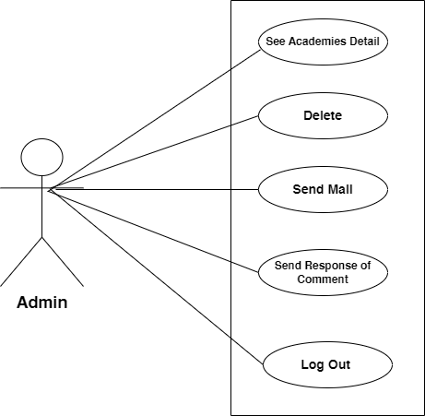

**Figure 4.1: Admin Use Case Model**

* + 1. **Academy Admin Use Case Model**

The academy admin also plays a crucial role in this web application. The Academy admin first registers themselves on the ETEA website. Then, they can perform various actions such as creating meetings with teachers, sending emails to teachers and students, viewing reports of teachers and students, adding subjects, posting problems, providing answers to posts from other academy users, sending emails to any academy, and responding to user comments. The use case diagram illustrating the roles of the admin is depicted below.

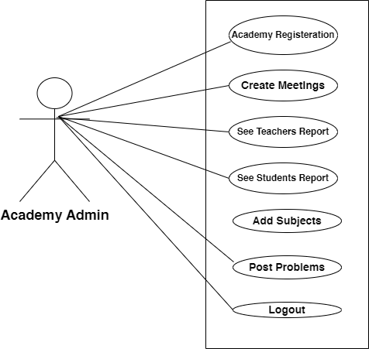

**Figure 4.2: Academy Admin Use Case Model**

* + 1. **Teacher Use Case Model**

Teachers have an important role on this website. They start by signing up and registering with the academy. Once registered, they can attend meetings where they share ideas and discuss important topics. Teachers are also responsible for creating quizzes and assignments for students to complete. They can send and receive messages to communicate directly with their students. Teachers can post problems or questions for students to solve, and they can provide answers to help students understand. When teachers are done using the website, they can log out to protect their account. Overall, teachers contribute to creating a positive and engaging learning environment on the website.

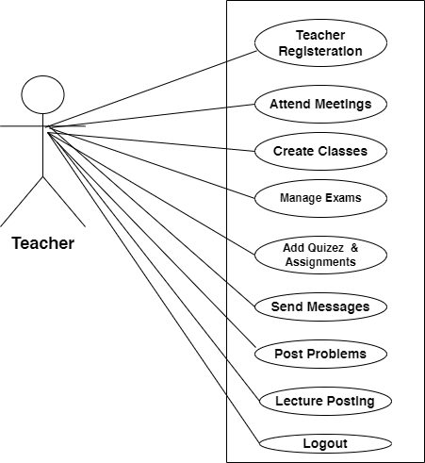

**Figure 4.3: Teacher Use Case Model**

* + 1. **Student Use Case Model**

On this website, students have various actions they can take. They start by registering themselves with the academy. Once registered, they can attend classes taught by teachers to learn and participate in their studies. Students also have the opportunity to take exams assigned by their teachers, such as quizzes or assignments, to demonstrate their understanding. Communication is important, so students can send and receive messages to/from their assigned teachers. This feature allows them to ask questions, seek clarification, or discuss course-related matters directly. Additionally, students can actively engage in the learning community by posting problems or questions and providing answers to others' problem posts. This promotes collaboration and enables students to learn from their peers. To enhance their learning experience, students can access a variety of resources such as documents, audios, and videos that are relevant to their studies. They can view and download these resources as needed. Finally, when students are finished using the website, they have the option to log out. This ensures the security and privacy of their account. Overall, these actions empower students to actively participate in their education, interact with teachers and peers, and access resources to support their learning journey.

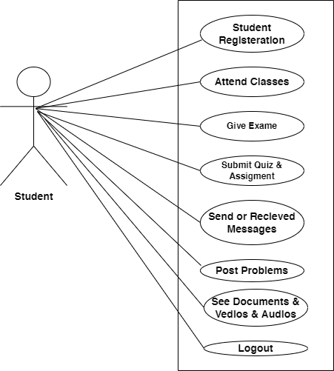

**Figure 4.4: Student Use Case Model**

* 1. **Level of Data Flow Diagram**

The following are the level of the Data Flow Diagram

* Level 0 DFD
* Level 1 DFD
* Level 2 DFD
  + 1. **Level 0 DFD**

The DFD level 0 outlines the "ETEA Preparation" website, involving four external entities. The admin entity holds complete authority, including the ability to delete academies and users. Teachers contribute by posting lectures, sharing materials, and guiding students. Students can join academies, access resources, and monitor progress. The Academy entity manages admissions, hires teachers, and coordinates activities within the system.

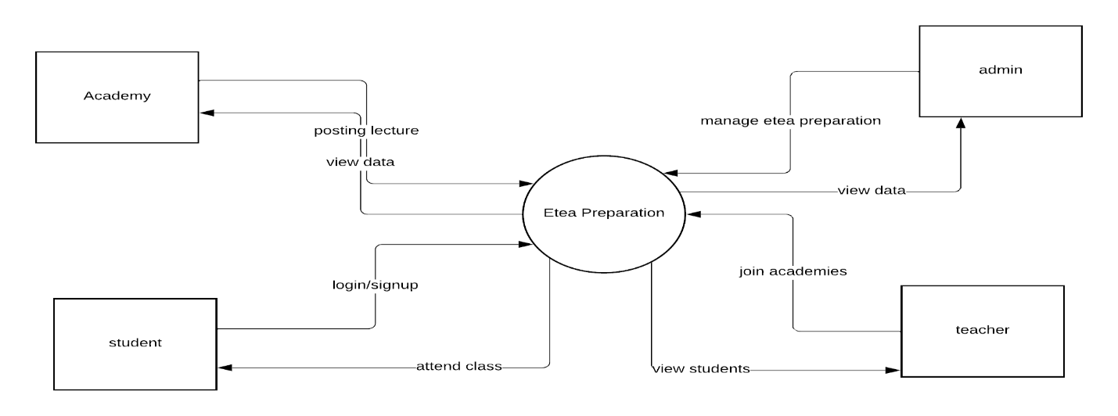

**Figure 4.5: Level 0 DFD**

* + 1. **Level 1 DFD**

The Level 1 Data Flow Diagram (DFD) focuses on the flow of data during User Signup and User Login processes. User Signup collects name, email, and password, validates the data, and saves it in the User Table. User Login verifies credentials against the User Table for authentication. The User Table stores user information for validation and authentication purposes.

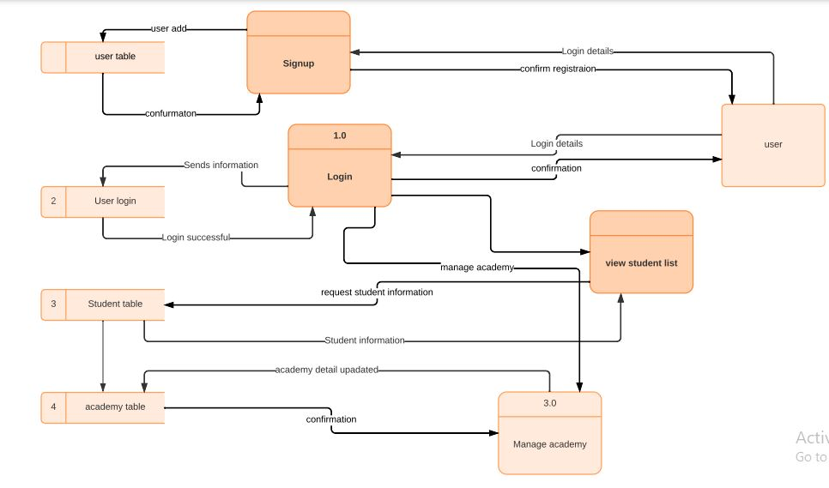

**Figure 4.6: Level 1 DFD**

* + 1. **Level 2 DFD**

The Level 2 Data Flow Diagram (DFD) illustrates the data flow within the Virtual Learning Management System. Teachers share lectures, quizzes, and assignments stored in respective repositories for student access and submissions. Real-time chat communication and email correspondence enhance interaction and record keeping.

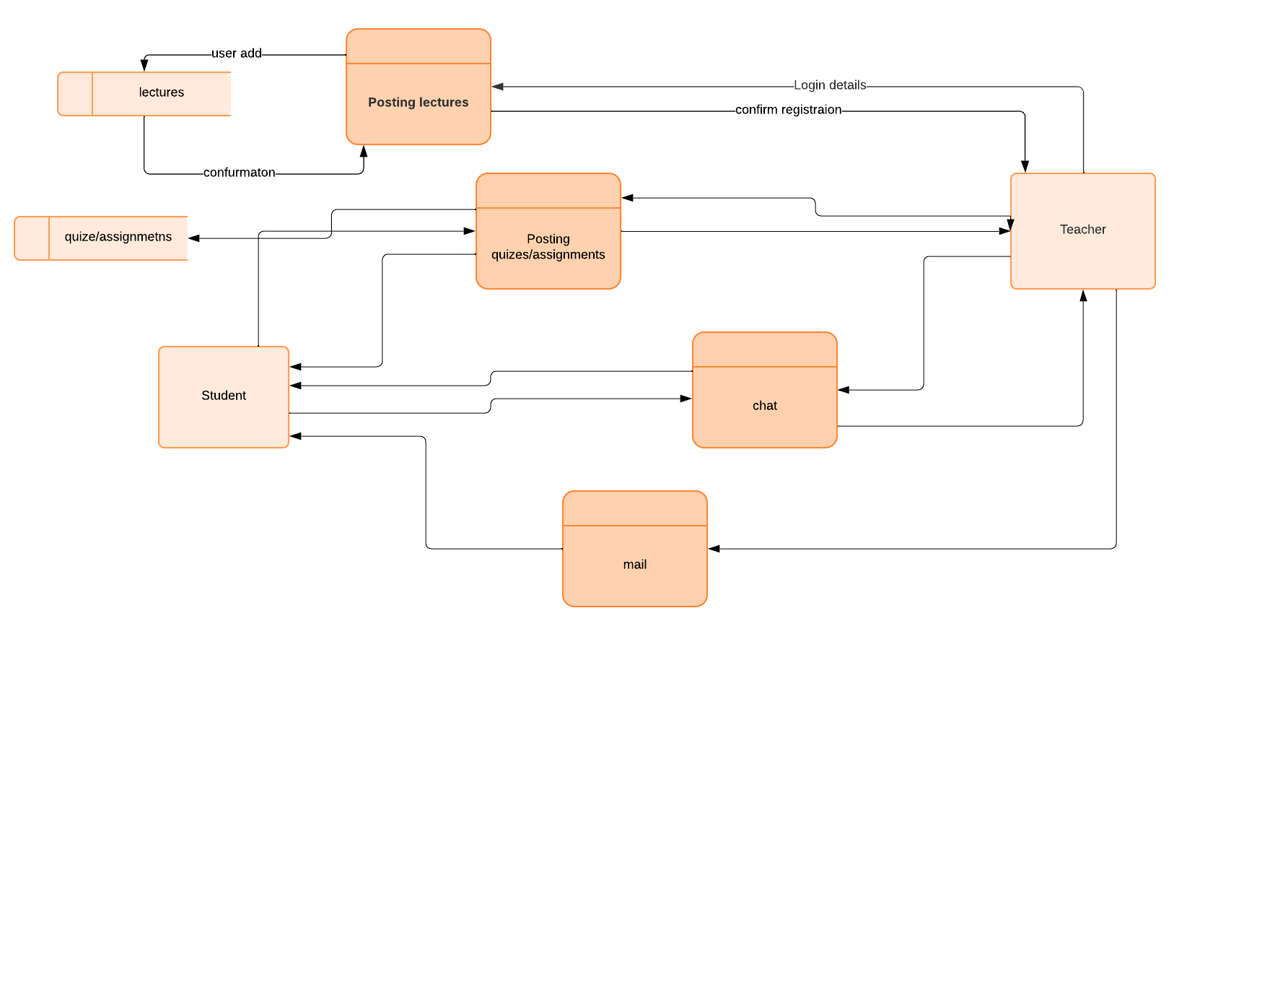

**Figure 4.7: Level 2 DFD**

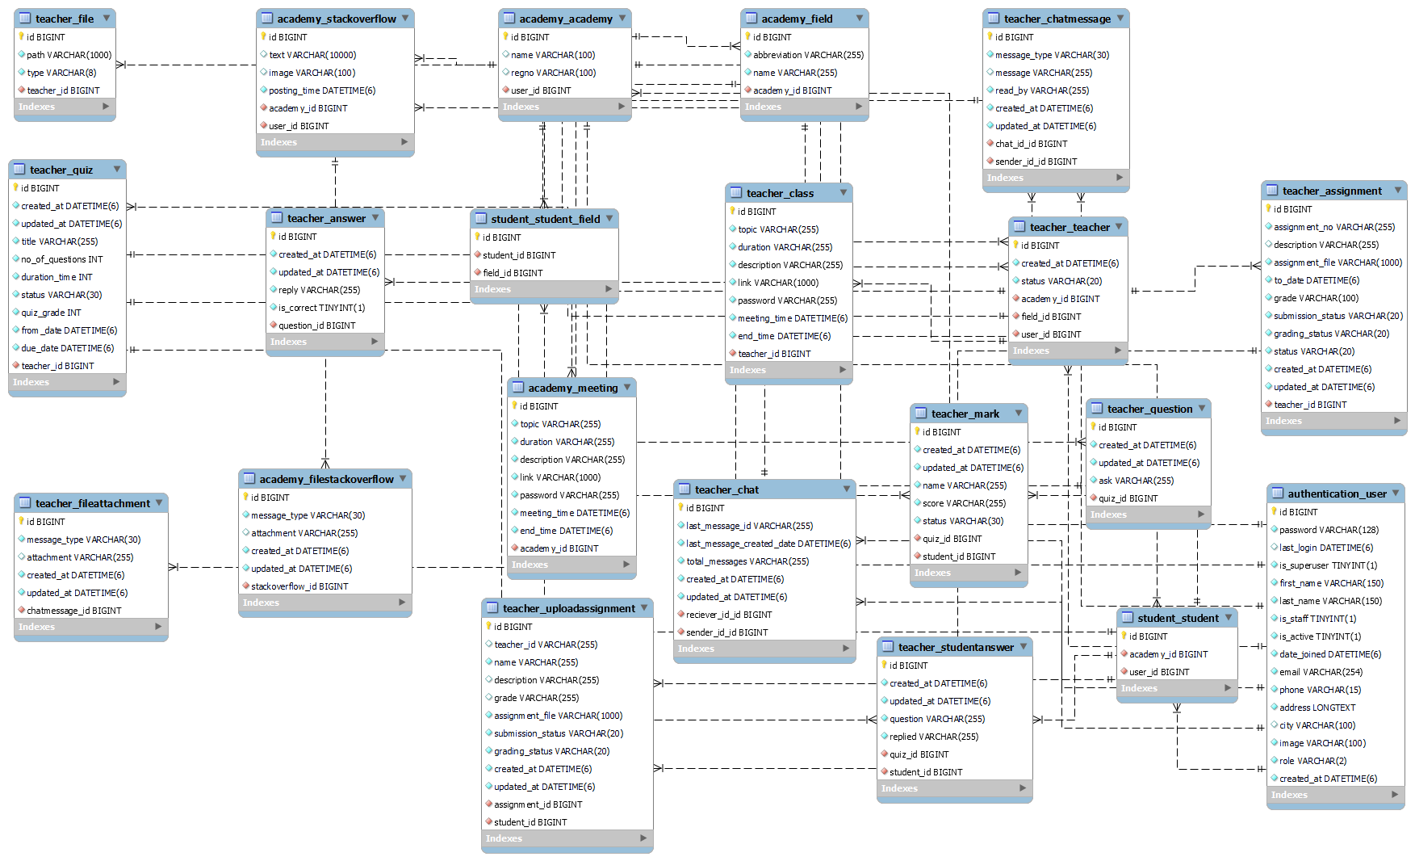

**Figure 4.8 Entity Relationship Diagram**

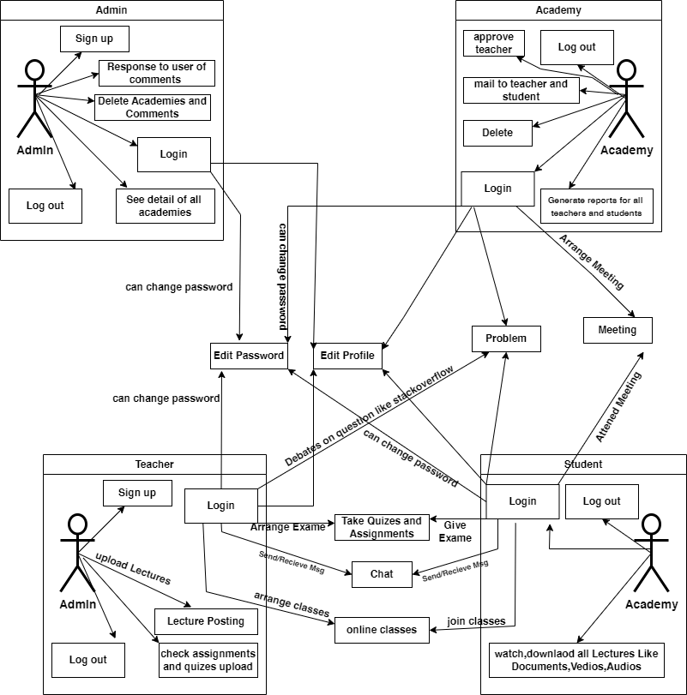

**Figure 4.9 ETEA Preparation System Design**

**CHAPTER 5**

**IMPLEMENTATION**

* 1. **Primary Programming Language**

The primary programming language can be chosen based on the development team's expertise and the system requirements. So our main primary programming language is given below:

* + 1. **Python**

Python is a high-level programming language known for its simplicity and readability. It is widely used for web development, data analysis, artificial intelligence, and various other applications. Python provides a vast ecosystem of libraries and frameworks that make development faster and more efficient. [5]

* + 1. **Django**

Django is a high-level Python web framework that follows the Model-View-Controller (MVC) architectural pattern. It provides a robust set of tools and features for building web applications. Django emphasizes reusability, scalability, and security. It includes an Object-Relational Mapping (ORM) system, a template engine, and built-in support for handling user authentication, database operations, and URL routing.

* + 1. **Django Rest Framework**

Django Rest Framework (DRF) is a powerful and flexible toolkit for building Web APIs using Django. It extends the capabilities of Django to facilitate the development of RESTful APIs. DRF provides tools for serialization, authentication, authorization, and request/response handling. It simplifies the process of building APIs by following the principles of simplicity, flexibility, and reusability.

* + 1. **HTML**

HTML (Hypertext Markup Language) is the standard markup language used for creating web pages. It provides a structure for organizing and presenting content on the web. HTML uses tags to define the structure and elements of a webpage, such as headings, paragraphs, links, images, and forms.

* + 1. **CSS**

CSS (Cascading Style Sheets) is a stylesheet language used for describing the visual presentation of a document written in HTML or XML. It allows developers to define styles, layout, and design aspects of web pages. CSS separates the content and structure of a webpage from its presentation, enabling consistent styling across multiple web pages.

* + 1. **Bootstrap**

Bootstrap is a popular front-end framework that provides a collection of pre-designed components, styles, and JavaScript plugins. It simplifies the process of building responsive and mobile-first websites. Bootstrap offers a grid system, responsive breakpoints, CSS classes, and ready-to-use UI components, allowing developers to create visually appealing and responsive web interfaces.

* + 1. **JavaScript**

JavaScript is a programming language primarily used for creating interactive and dynamic web content. It enables client-side scripting, allowing developers to manipulate webpage elements, handle events, and communicate with servers. JavaScript is widely supported by modern web browsers and is an essential component for enhancing user experience and adding interactivity to web applications.

* + 1. **React**

React is a JavaScript library for building user interfaces. It allows developers to create reusable UI components and efficiently update the user interface based on changes in application state. React follows a component-based architecture and uses a virtual DOM (Document Object Model) for efficient rendering. It is widely used for building single-page applications (SPAs) and is known for its performance, simplicity, and reusability.

* 1. **Integrated Development Environments (IDEs)**

IDEs provide a comprehensive development environment with features like code editing, debugging, version control integration, and project management. So our main Integrated Development Environments (IDEs) is given below:

* + 1. **Visual Studio Code**

Visual Studio Code (VS Code) is a free and open-source source code editor developed by Microsoft. It is a lightweight yet powerful tool that provides a wide range of features for editing and debugging code.

VS Code supports multiple programming languages and offers extensive customization options, making it popular among developers across different domains. It includes features such as syntax highlighting, code completion, code refactoring, debugging capabilities, version control integration, and an integrated terminal.

One of the key strengths of Visual Studio Code is its vast ecosystem of extensions. Users can install extensions to enhance the functionality of the editor and tailor it to their specific needs. There are extensions available for various programming languages, frameworks, and tools, providing additional features, themes, and integrations.

Visual Studio Code also offers a user-friendly interface with a well-organized layout and customizable settings. It provides a smooth and responsive editing experience, allowing developers to work efficiently and focus on their code. It runs on multiple platforms, including Windows, macOS, and Linux, making it accessible to a wide range of users.

Overall, Visual Studio Code is a versatile and widely adopted code editor that combines simplicity, performance, and extensibility, making it a preferred choice for developers working on different projects and programming languages.

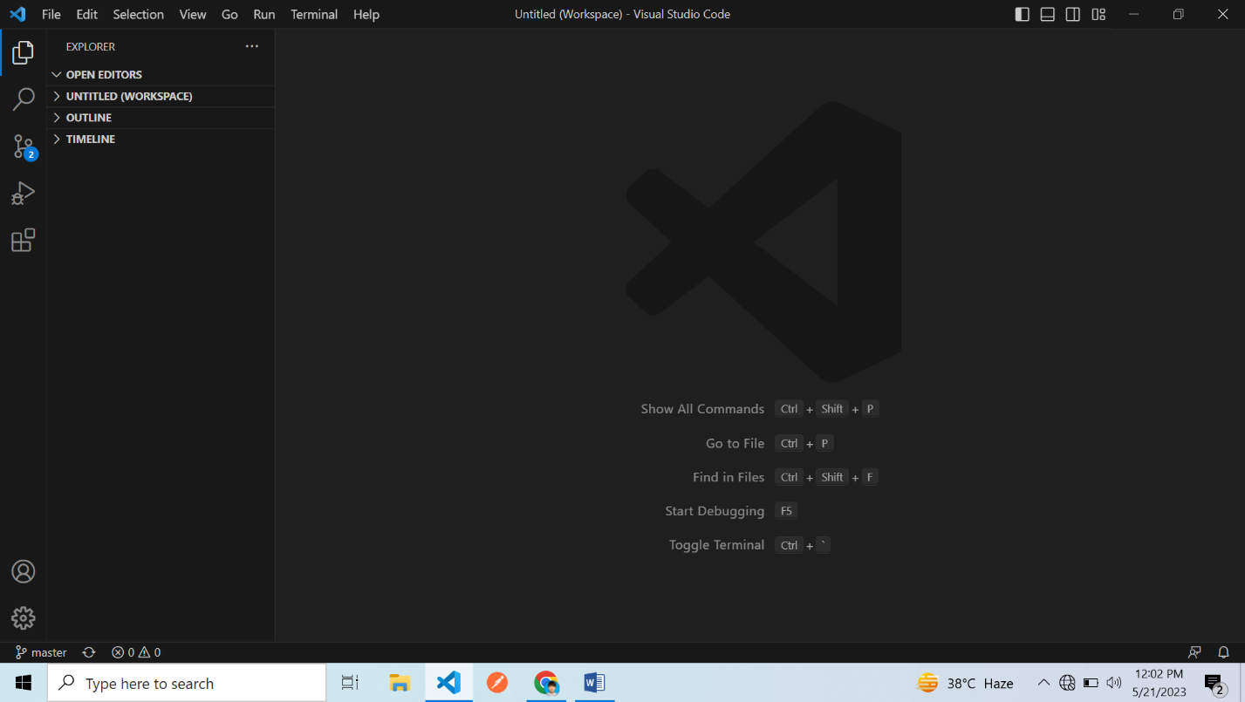

**Figure 5.1: Visual Studio Code Interface**

* 1. **Database Management System**

A Database Management System (DBMS) is software that enables users to create, manage, and manipulate databases. It provides an interface for interacting with databases and offers a set of tools and functionalities for organizing, storing, retrieving, and manipulating data efficiently. Our main DBMS for our project is MySQL.

* + 1. **MYSQL**

MySQL is an open-source Relational Database Management System (RDBMS) that is widely used for managing and manipulating structured data. It provides a robust and scalable platform for storing, organizing, and retrieving data efficiently. Key features of MySQL include:

* MySQL follows a relational database model, where data is organized into tables with predefined schemas. It supports the SQL language for querying and manipulating the data.
* MySQL enforces data integrity through various constraints, such as primary keys, foreign keys, unique constraints, and check constraints. These constraints ensure that data is consistent and accurate.
* MySQL can handle large amounts of data and supports high-performance applications. It offers features like replication, clustering, and partitioning to distribute the data and handle increased workloads.
* MySQL provides robust security features to protect the data. It supports user authentication, access control, and encryption of data in transit and at rest.
* MySQL offers features like replication and failover mechanisms to ensure high availability of the database. Replication allows data to be replicated across multiple servers for improved performance and fault tolerance.
* MySQL supports stored procedures and triggers, which are stored in the database and can be executed as a part of a query or triggered by specific events. These help in implementing complex business logic and automating tasks.

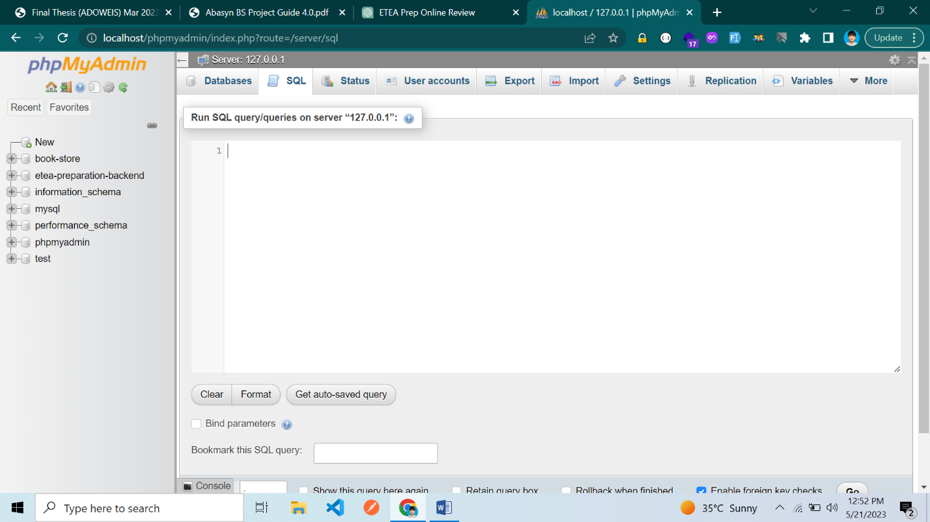

**Figure 5.2: MYSQL Interface**

* 1. **Tools for Software Testing**

Tools for software testing are software applications or platforms designed to assist testers in planning, executing, and managing software testing activities. These tools provide a range of functionalities and features that help ensure the quality, reliability, and performance of software applications. Some common categories of software testing tools include:

* Test Automation Tools
* Performance Testing Tools
* Security Testing Tools
* Load Testing Tools
* Test Data Management Tools
* Defect Tracking Tools
* Code Review Tools
* Continuous Integration/Continuous Delivery (CI/CD) Tools
* Monitoring and Logging Tools.

So our main tool for software testing is postman.

* + 1. **Postman**

Postman is a popular API testing tool that enables testers to send requests, automate tests, and validate responses for RESTful APIs. It provides a user-friendly interface for designing and executing API tests.

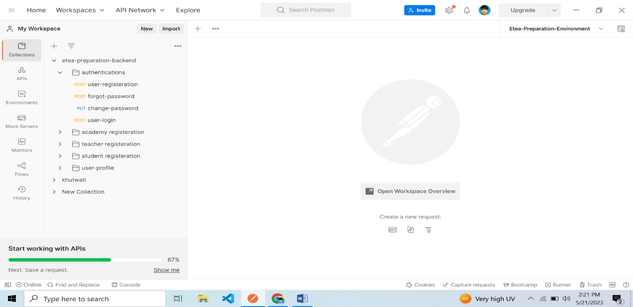

**Figure 5.3: Postman Interface**

* 1. **Tools for Project Management and Communication**

Software applications designed to help plan, organize, and track project progress, including tasks, timelines, resources, and collaboration. Examples include Trello, Asana, Jira, and Microsoft Project.

Applications or platforms that facilitate communication and collaboration within project teams, allowing for real-time messaging, video conferencing, file sharing, and document collaboration. Examples include Slack, Microsoft Teams, Zoom, and Google Meet.

I have used in ETEA Preparation Tools for project management is notion and for communication is slack.

* + 1. **Notion**

Notion is a versatile project management tool that combines note-taking, task management, and collaboration features in a unified workspace. It allows users to create and organize documents, databases, and boards to manage projects effectively.

* + 1. **Slack**

Slack is a communication and collaboration platform widely used for project management and team communication? It offers a range of features that facilitate real-time messaging, file sharing, and integration with other tools. Here are some key aspects of Slack:

* Channels
* Messaging
* File Sharing
* Integration
* Notifications and Alerts
* Search and Archiving
  1. **Version Control System**

A Version Control System (VCS) is a software tool that tracks and manages changes to files over time. It allows multiple users to collaborate on a project by keeping a record of different versions of files, facilitating teamwork, and providing a history of changes. VCS enables users to track changes, revert to previous versions, manage conflicts, and merge changes made by multiple contributors.

I have used in ETEA Preparation Version Control System is Git.

* + 1. **Git**

Git is a widely used distributed version control system (DVCS) designed to track changes in files and coordinate work among multiple contributors. It provides a framework for managing project source code and other files, allowing developers to collaborate efficiently [8]. Some key aspects of Git include:

* Distributed
* Version Tracking
* Branching and Merging
* Collaboration
* Conflict Resolution
* Integration and Ecosystem

Git is widely adopted in software development due to its speed, efficiency, and robustness. It provides a reliable and flexible version control system that supports both small and large-scale projects.

* 1. **User interface**

During the interface design process, our main focus was to create a clean, clear, and simple design that users can easily understand. We kept the design simple, following some of the main rules of user interface design. Here are some screenshots illustrating our design approach. [6]

* + 1. **Home Page**

The home page includes navigation menus through which users can navigate to different types of functionalities. In our project, we have components for Home, About Us, Contact Us, Academies, and Sign In. Each of these components has its own functionality. When a user clicks on a menu item, they are directed to the respective component where they can access the specific functionality.



**Figure 5.4: Home Page**

* + 1. **About Us**

When the user clicks on the "About Us" button, they can access a page that provides detailed information about ETEA preparation.

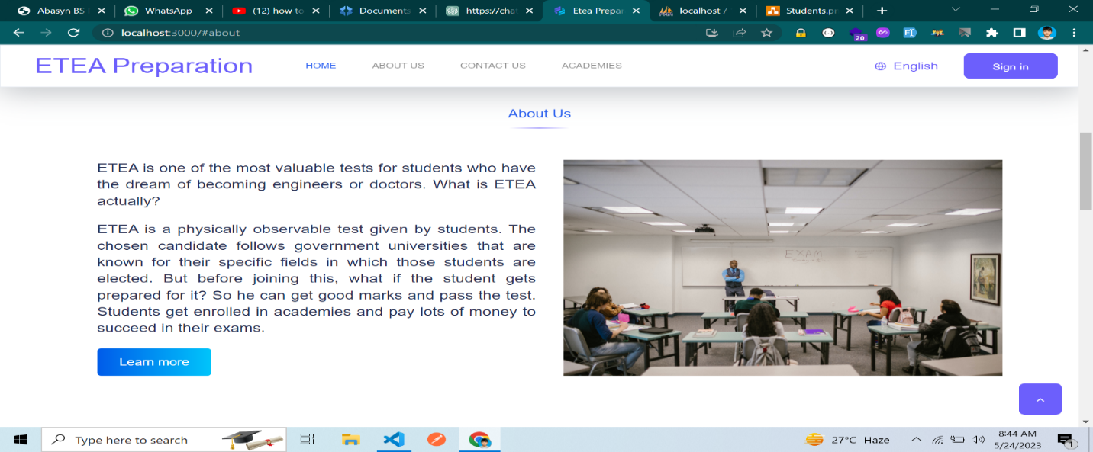

**Figure 5.5: About Us**

* + 1. **Contact Us**

When the user clicks on the "Contact Us" button, they are directed to the Contact Us page where they can get in touch with ETEA Preparation.

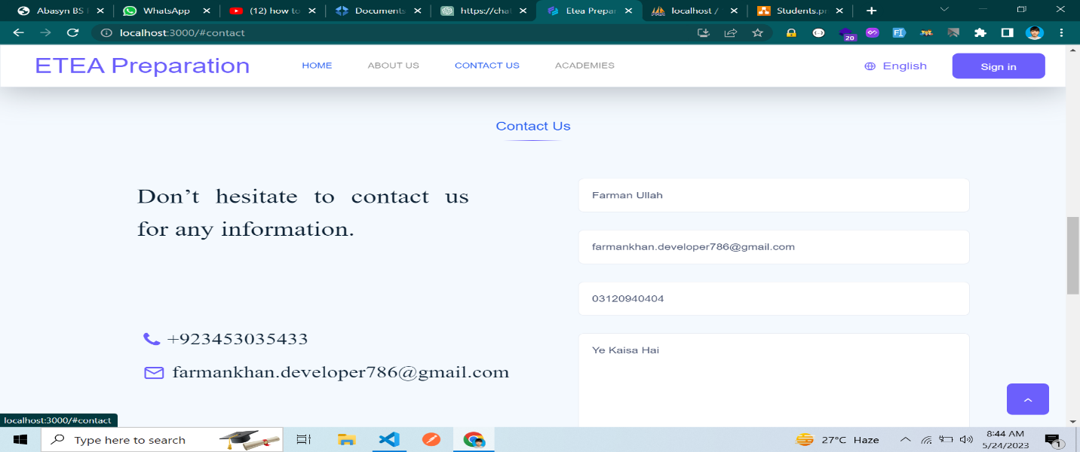

**Figure 5.6: Contact Us**

* + 1. **Academies**

When the user clicks on the "Academies" button, they can find a list of all the academies that are registered with the ETEA Preparation.

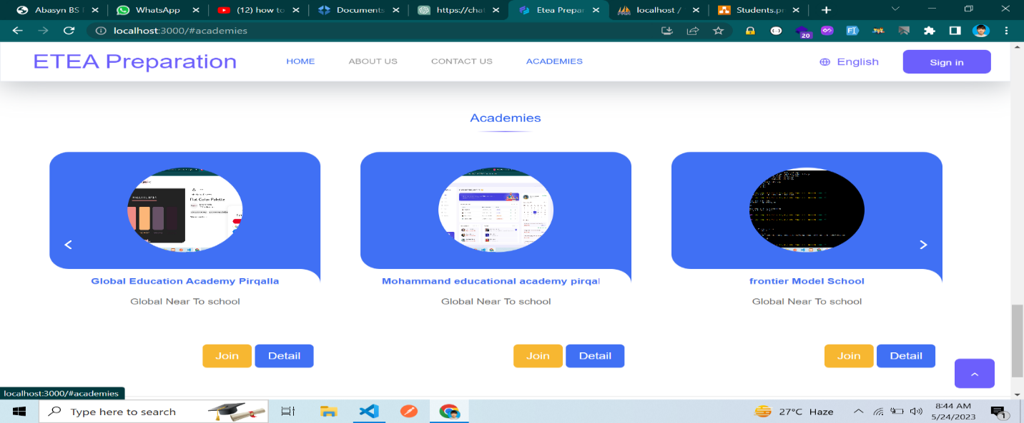

**Figure 5.7: Academies**

* + 1. **Login**

This login page is designed to be used by all types of users on the website, including admin, academy admin, teachers, and students. Once a user is authenticated, they can access their respective functionalities based on their role. For example, the admin can perform tasks such as adding, deleting, and updating data, as well as other administrative functions. Similarly, academy admins, teachers, and students will have access to their own specific functionalities within the website.

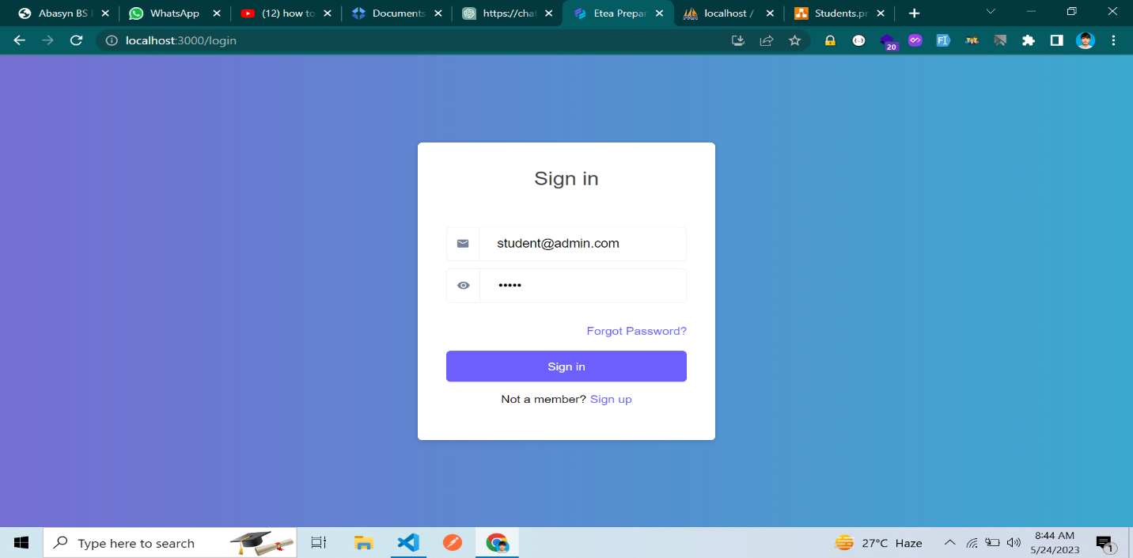

**Figure 5.8: Login Page**

* + 1. **Admin Dashboard**

When the admin is authenticated, the dashboard is displayed, providing an overview of important information and features specific to the admin. The dashboard may include various components, such as: Academies, comments, profile, edit profile, change password and sign out

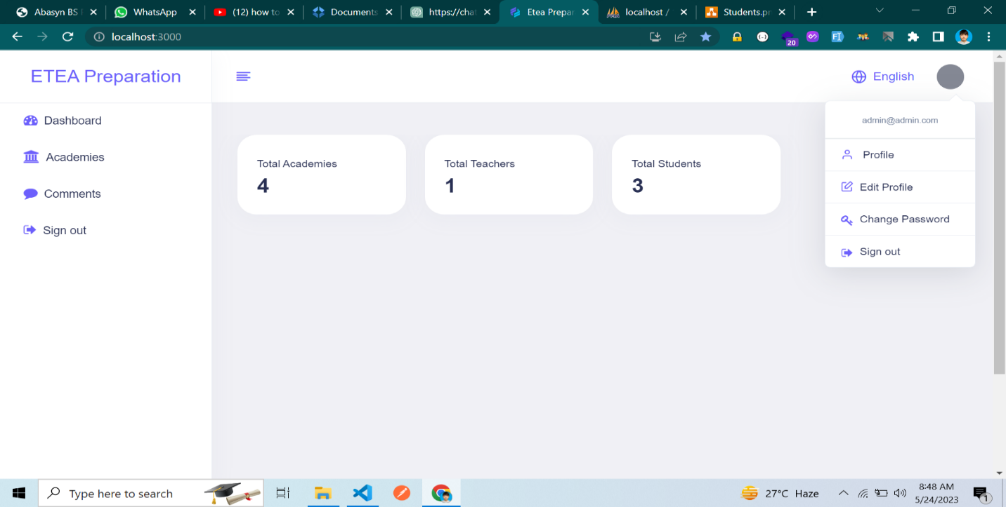

**Figure 5.9: Admin Dashboard**

* + 1. **Academies**

When the admin clicks on the "Academies" button, it allows them to manage the registered academies. This functionality provides options to view detailed information about each academy, send emails to academies, and delete academies if necessary.

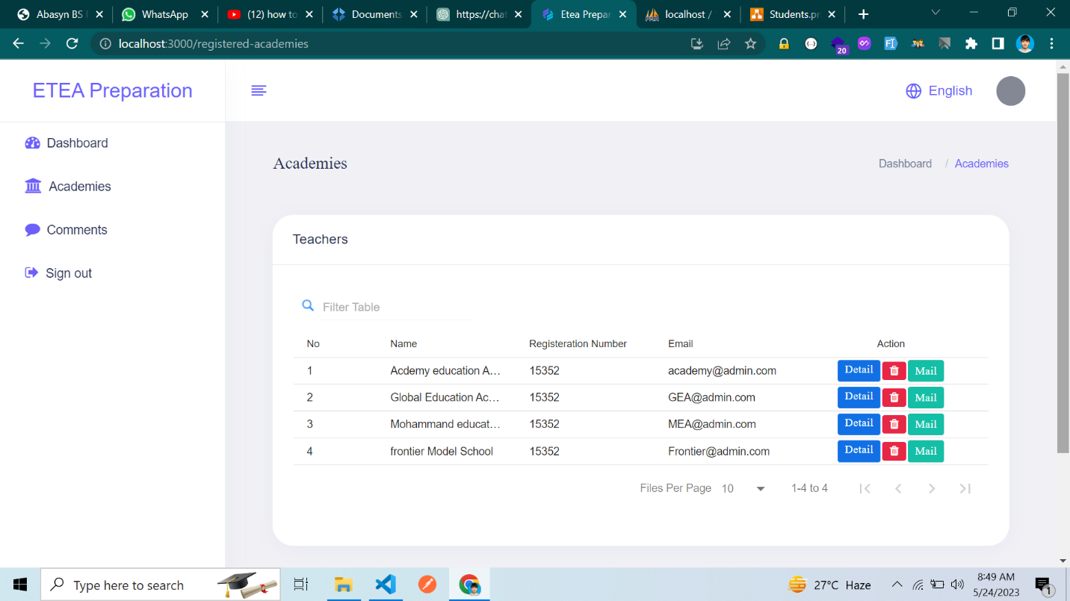

**Figure 5.10: List of All Academies**

* + 1. **Comments**

This section enables the admin to review and manage user comments or feedback received on the website. The admin can approve, delete, or respond to comments as necessary.

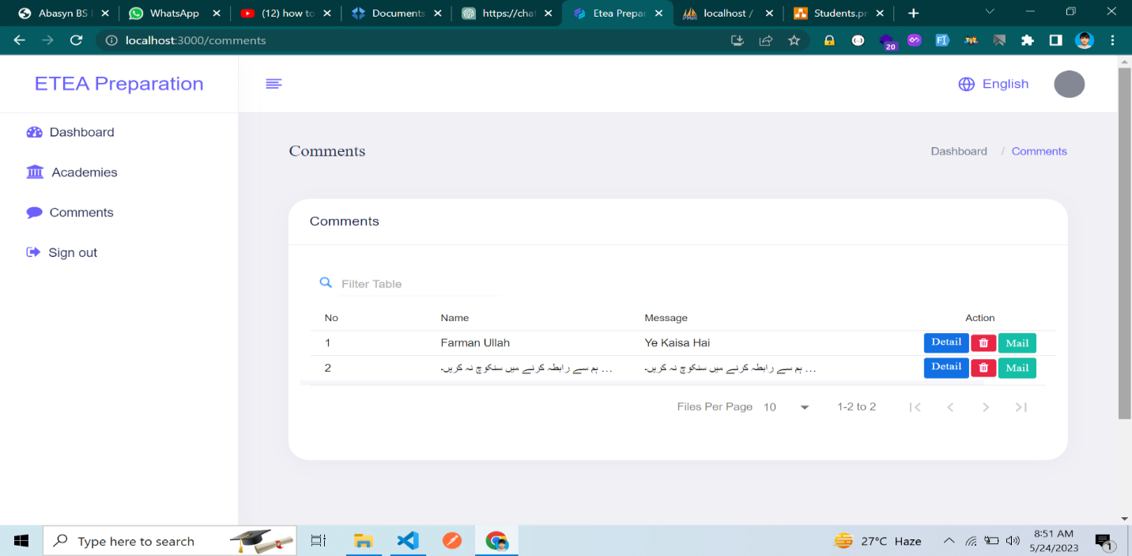

**Figure 5.11: List of All Comments**

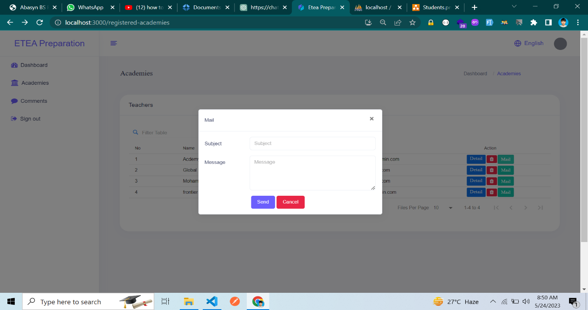

**Figure 5.12: Mail**

* + 1. **Academy Dashboard**

When the academy admin is authenticated, the dashboard is displayed, offering an overview of important information and features specific to the academy admin. The dashboard may include various components such as Meetings, Teachers, Students, Subjects, Post Problem, Profile, Edit Profile, Change Password, and Sign Out.

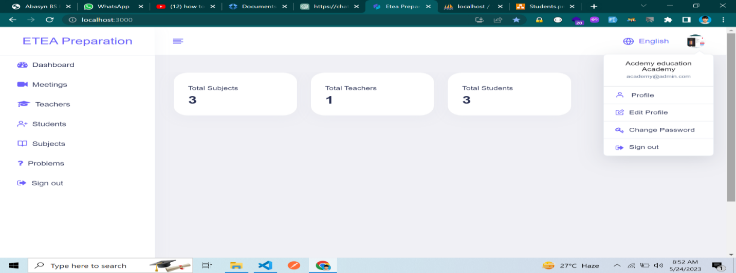

**Figure 5.13: Academy Dashboard**

* + 1. **Profile**

This component displays the academy admin's profile which is given below:

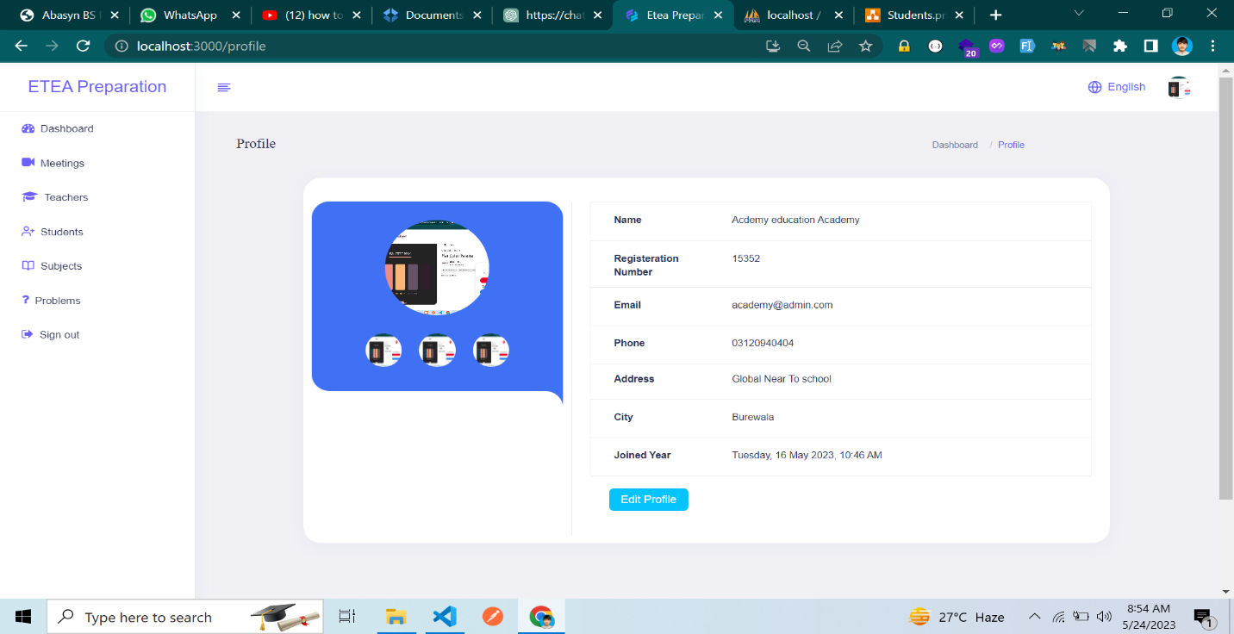

**Figure 5.14: Academy Profile**

* + 1. **Edit Profile**

In this section, the academy admin can manage their own profile.

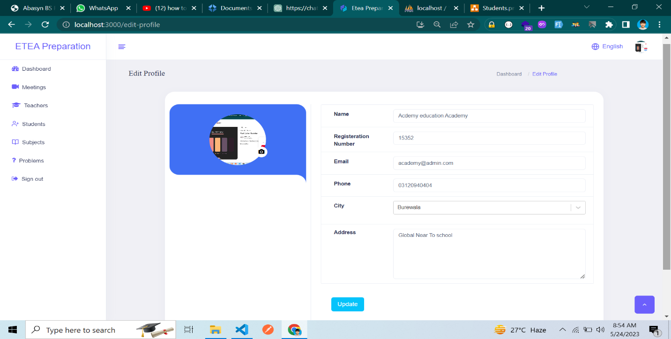

**Figure 5.15: Academy Edit Profile**

* + 1. **Change Password**

In this section, the academy admin can change their own password.

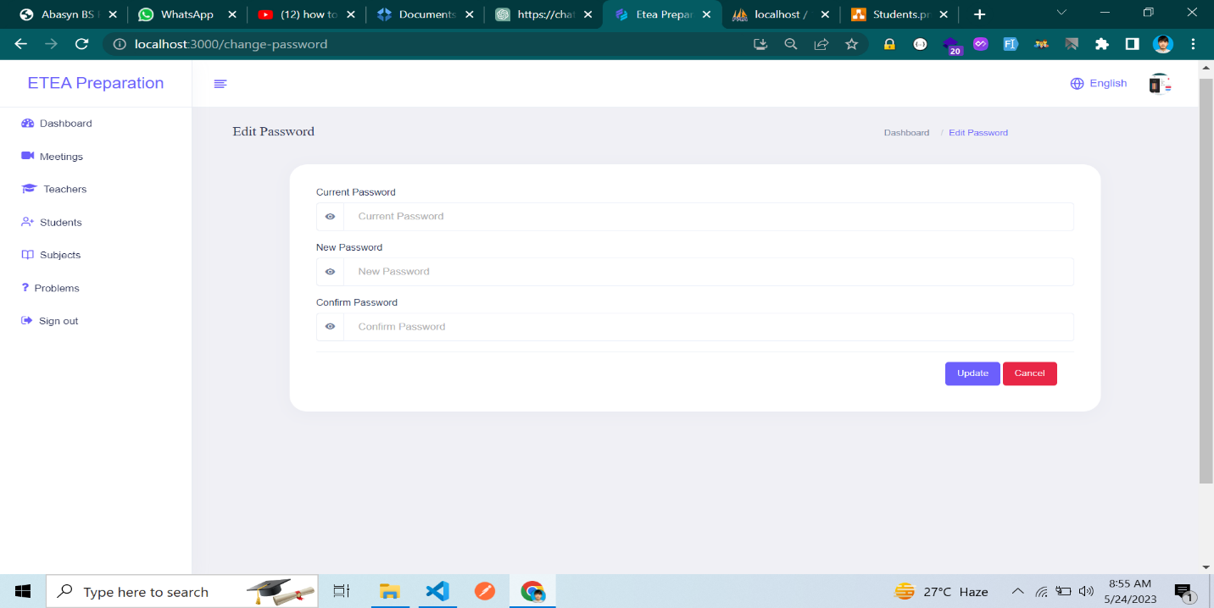

**Figure 5.16: Change password**

* + 1. **List of Meetings**

This section allows the academy admin to manage meetings or appointments, schedule new meetings, view upcoming meetings.

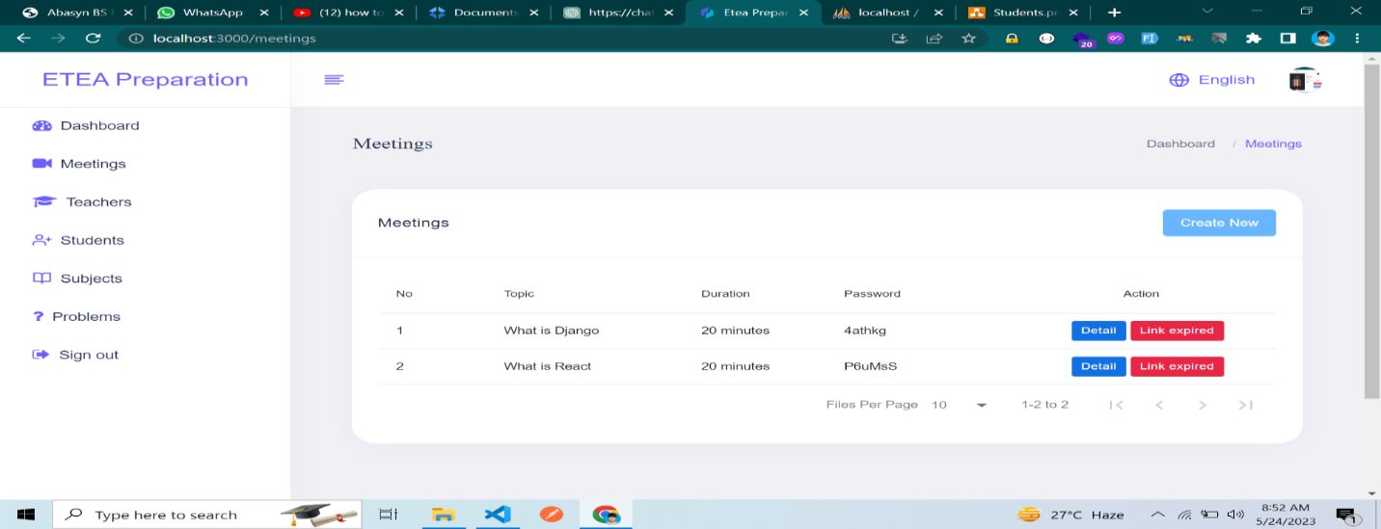

**Figure 5.17: List of Meetings**

* + 1. **Teachers**

In this section, the academy admin can perform several actions, including deleting teachers, viewing all teacher reports, sending emails to teachers, and accessing detailed information.

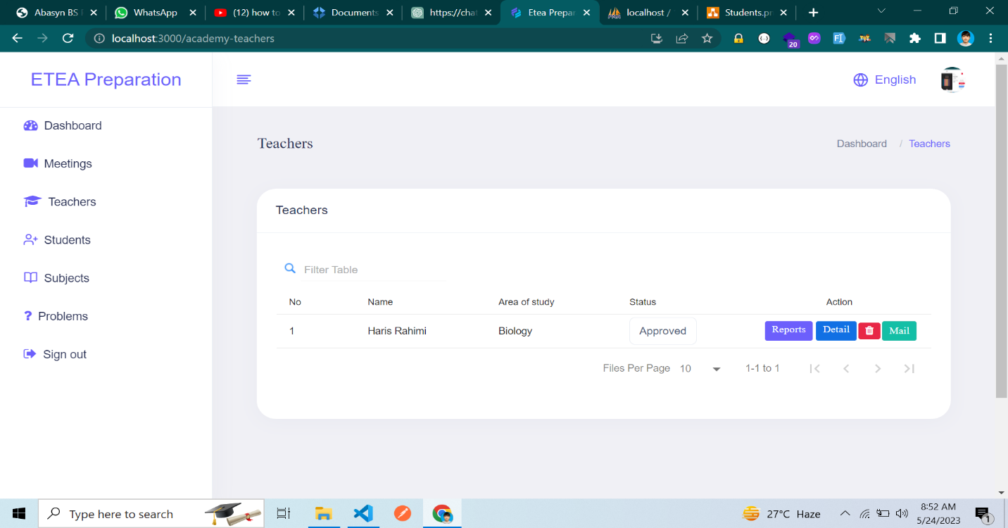

**Figure 5.18: List of Teachers**

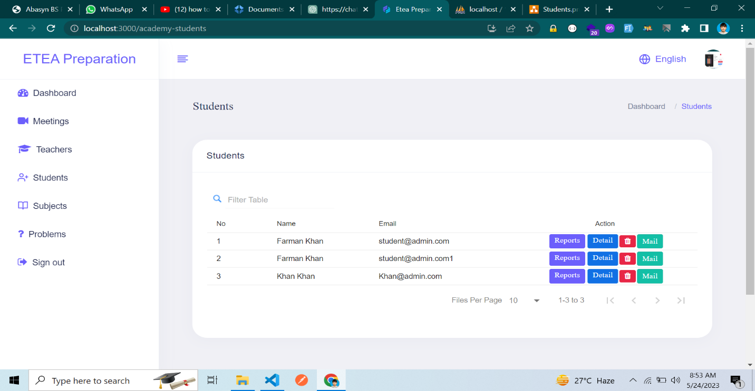**Figure 5.19: List of Students**

* + 1. **List Of Subjects**

This section allows the academy admin to manage subjects taught in the academy.

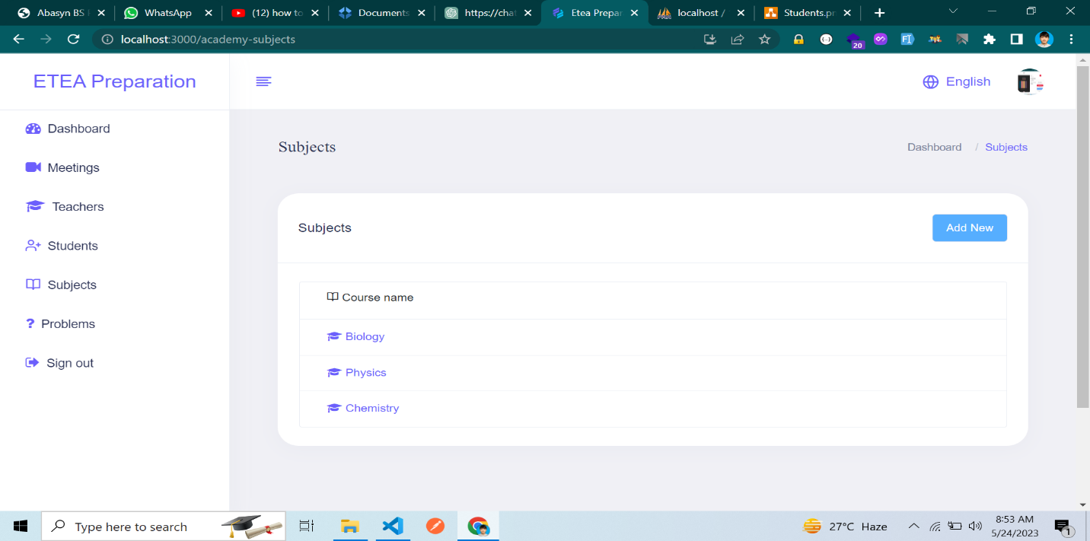**Figure 5.20: Subjects**

* + 1. **Problems**

This feature enables the academy admin to post problem statements or assignments for students. They can create new problem posts, manage existing ones, and facilitate communication with students regarding problem-solving.

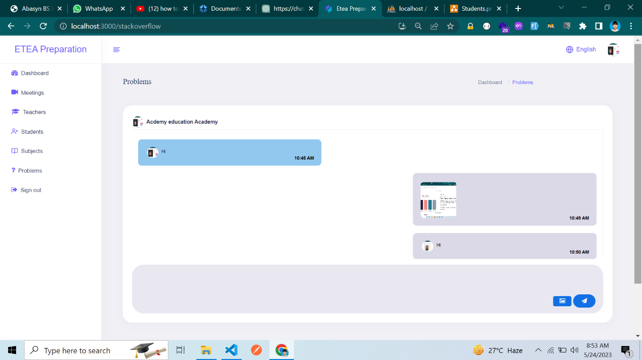**Figure 5.21: Problems**

* + 1. **Teacher and Student Dashboard**

When the Teacher is authenticated, the dashboard is displayed, offering an overview of important information and features specific to the Teacher. The dashboard may include various components such as Meetings, Live classes, Activity, Messages, Lecture Posting, Profile, Edit Profile, Change Password, and Sign Out.

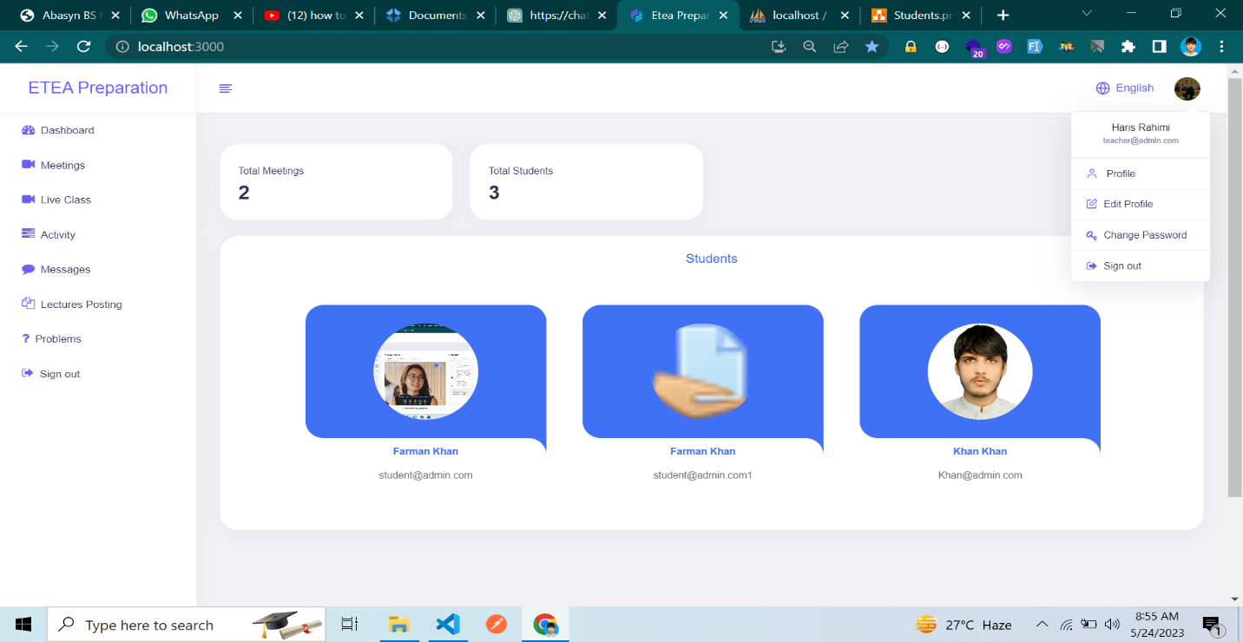

**Figure 5.22: Teacher Dashboard**

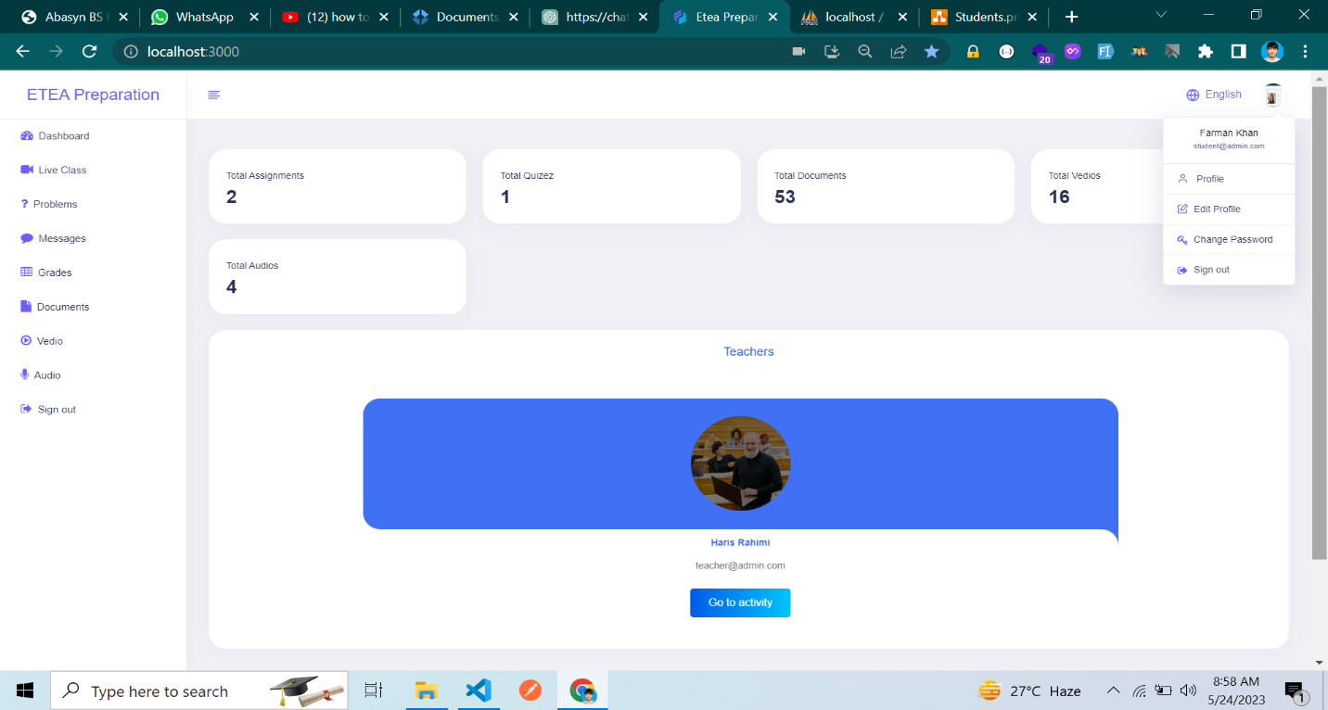

**Figure 5.23: Student Dashboard**

* + 1. **Classes**

In this section, the teacher can create a link for the class, allowing students to attend it. Both the teacher and the students can also view the details of the created class.

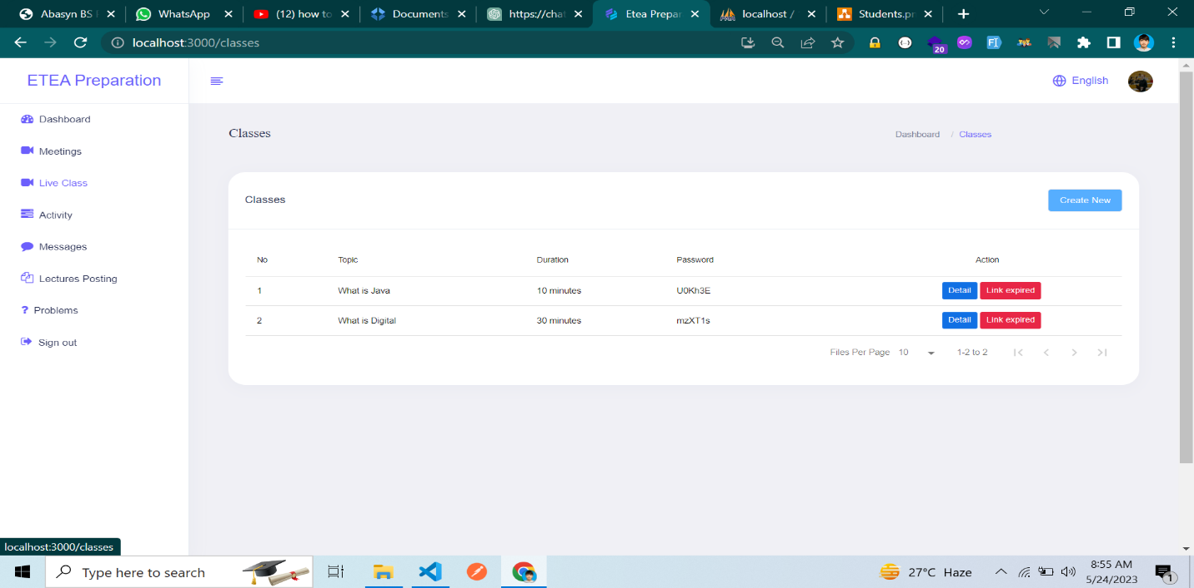

**Figure 5.24: Classes**

* + 1. **Assignment and Quizzes**

In this section, from the teacher's side, the teacher assigns assignments and quizzes to the students. The students then submit their assignments and quizzes within the given timeframe.

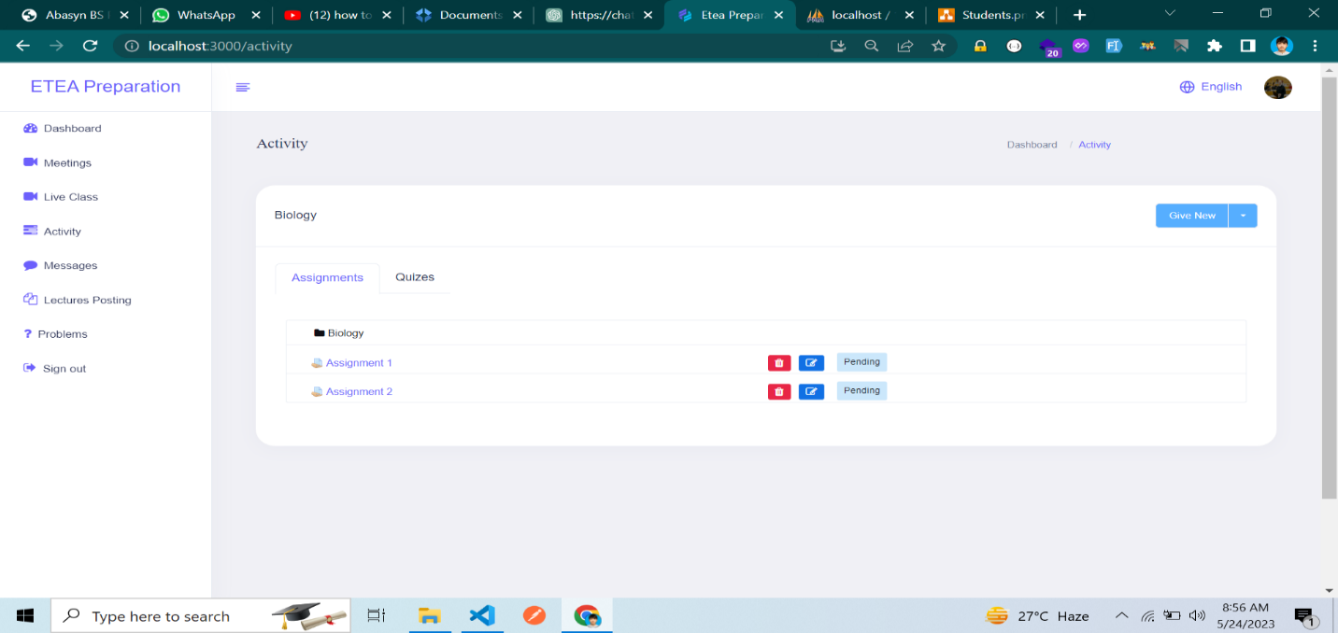**Figure 5.25: Teacher Side Assignments**

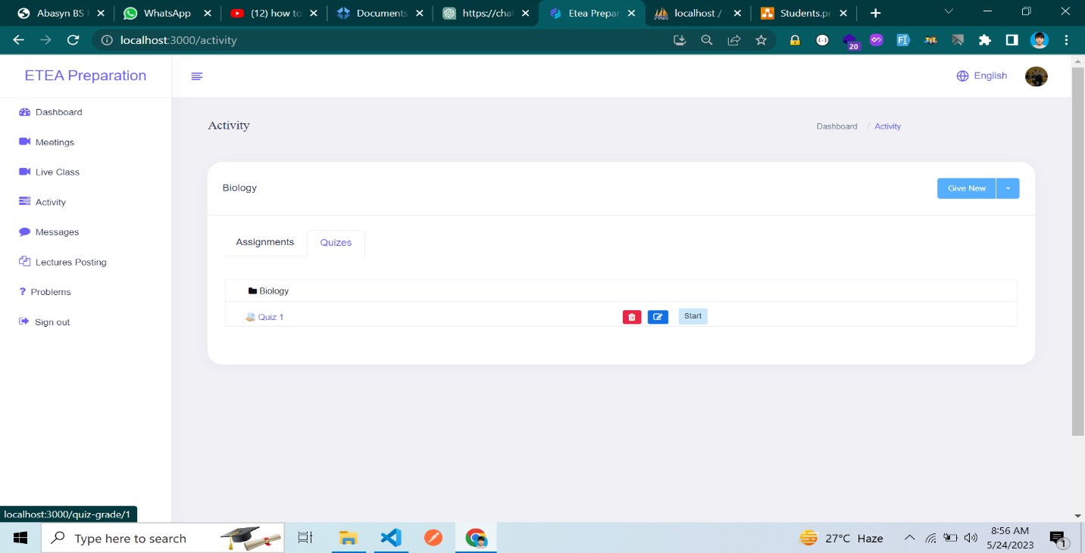

**Figure 5.26: Teacher Side Quizzes**

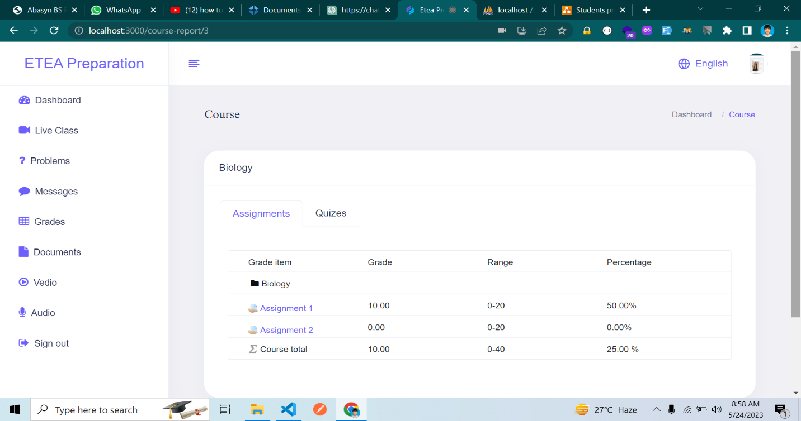

**Figure 5.27: Student Side Assignments**

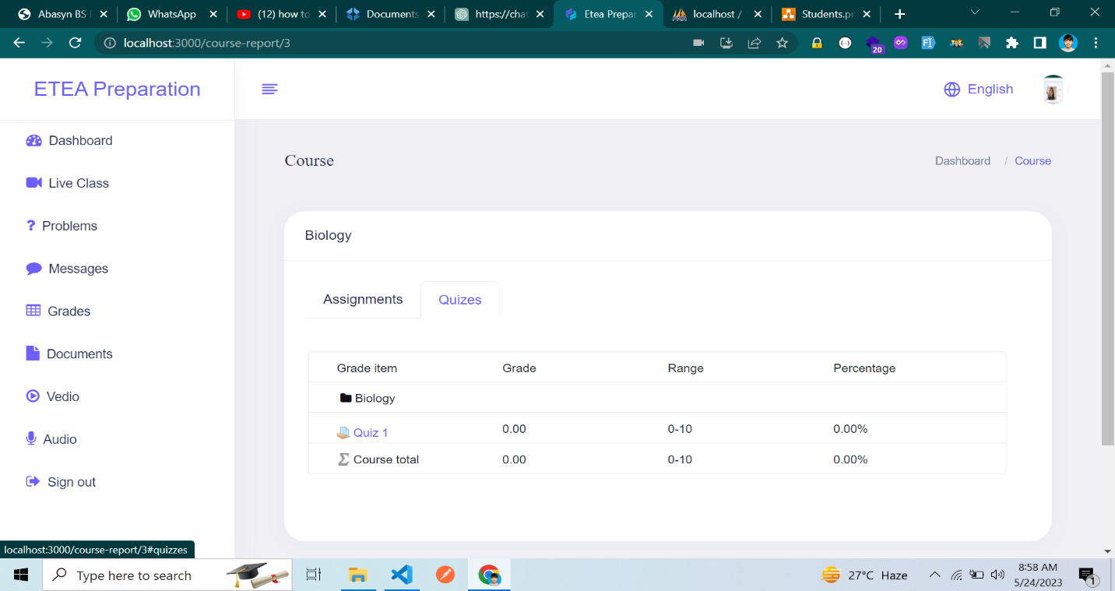

**Figure 5.28: Student Side Quizzes**

* + 1. **Lectures**

In this section, students have the ability to download, watch, and listen to documents, videos, and audio files that have been uploaded by the teacher.

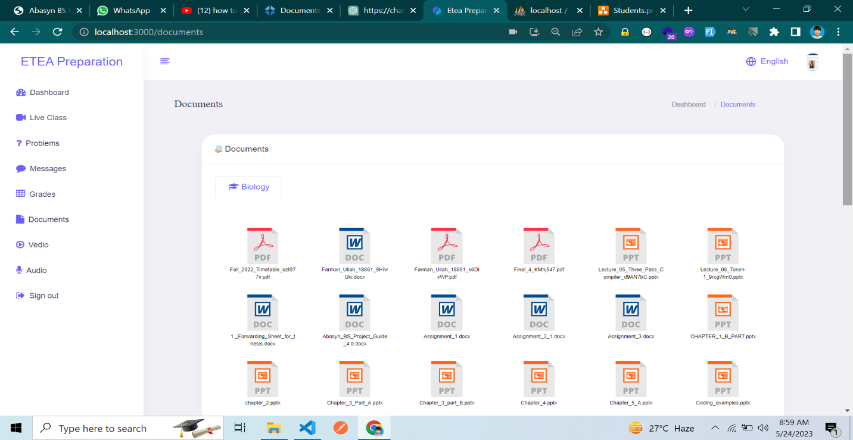

**Figure 5.29: List of Documents**

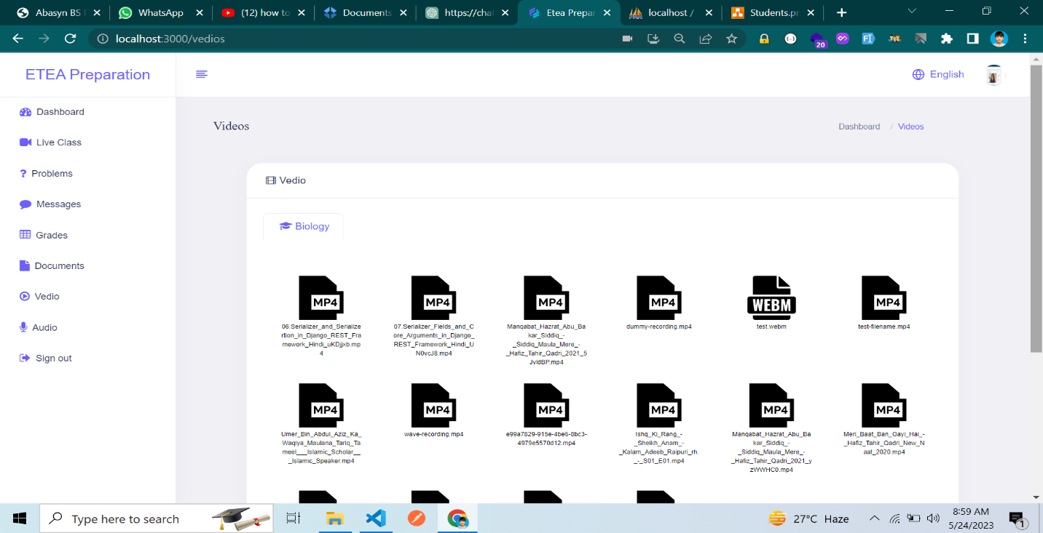**Figure 5.30: List of Videos**

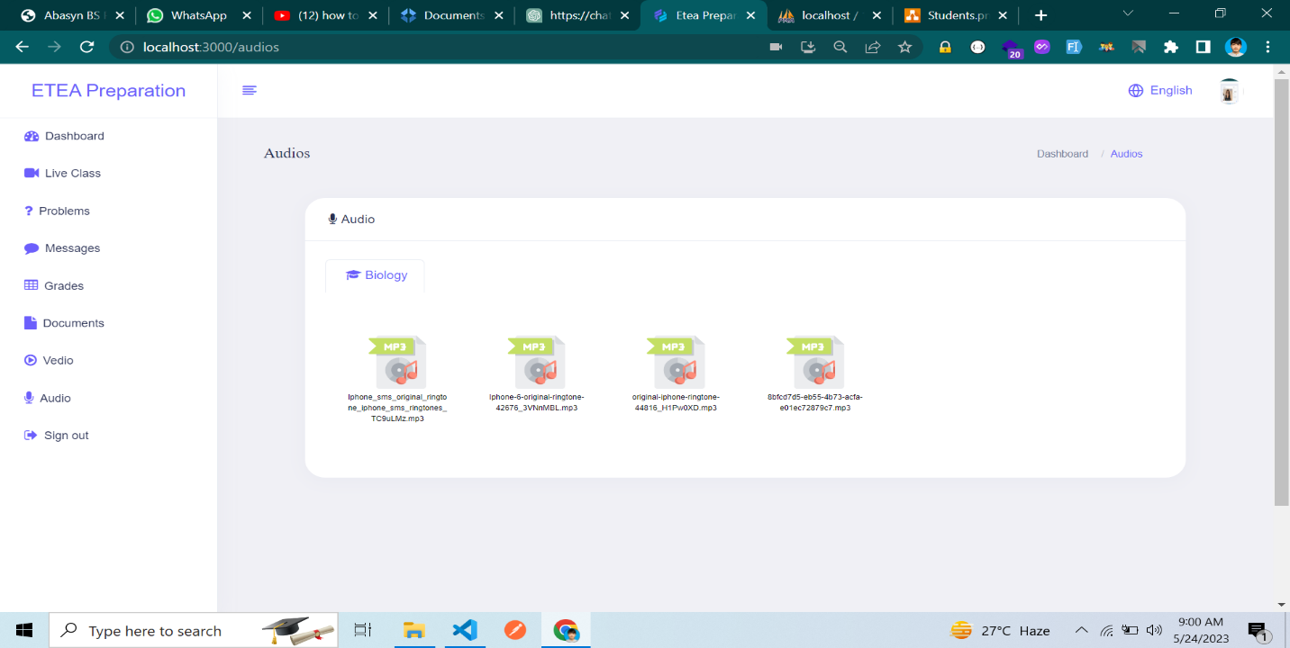**Figure 5.31: List of Audios**

* + 1. **Language Translations**

When student or teacher or academy admin or any user click on language button it shows this modal

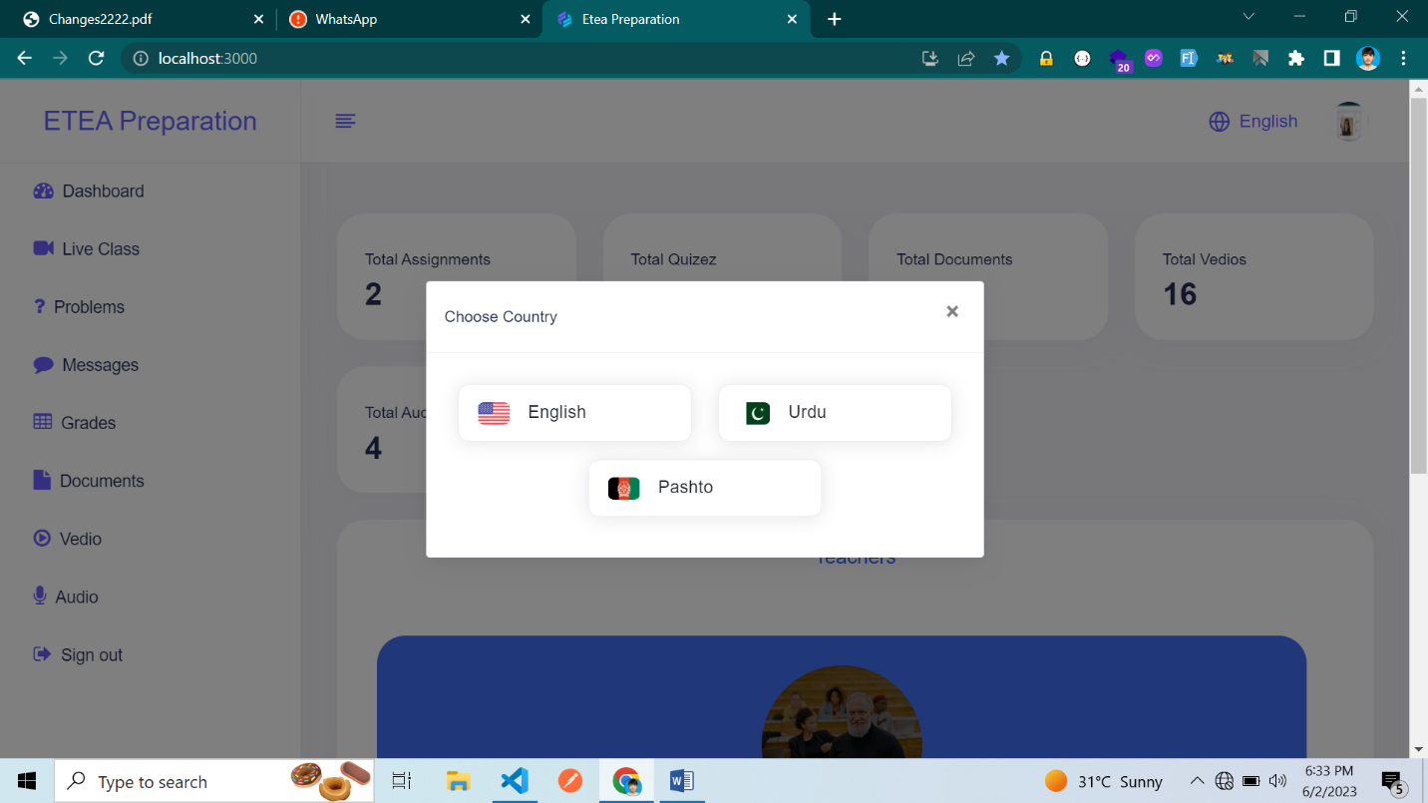

**Figure 5.32: Language Translation Modal**

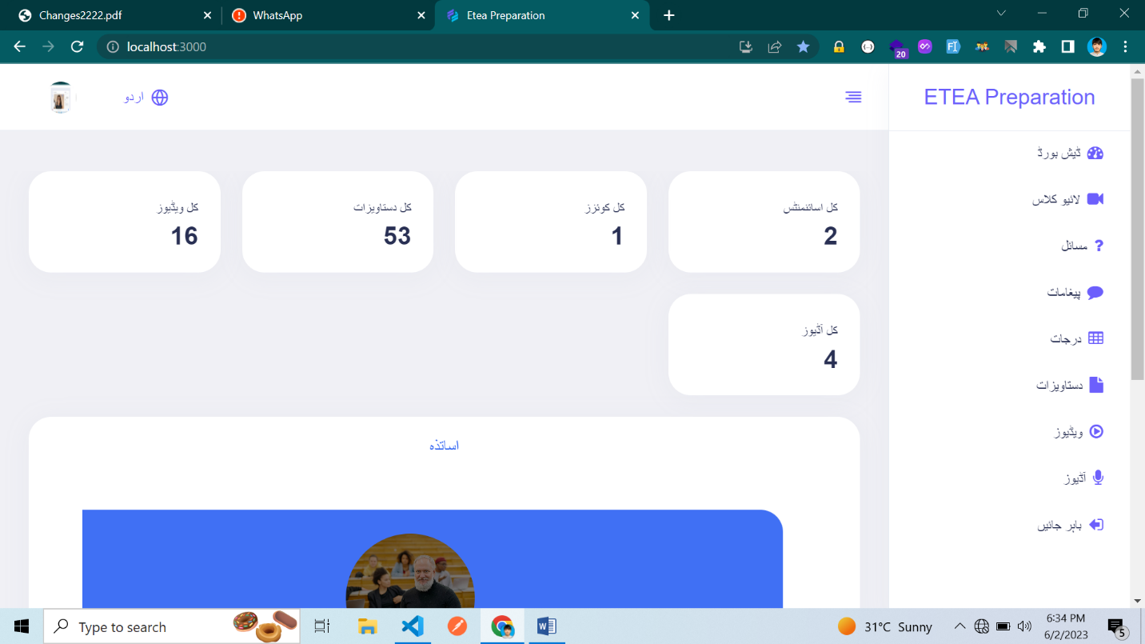

**Figure 5.33: Language Change**

**CHAPTER 6**

**TEST CASE SPECIFICATION**

* 1. **Introduction**

Test case specification refers to the process of documenting the details of individual test cases that are to be executed to verify the functionality, performance, or other aspects of a software system or application. It involves describing the inputs, expected outputs, preconditions, and post conditions for each test case, as well as any specific steps or procedures to be followed during testing. [13]

* 1. **Test Plan**

A test plan is a formal document that outlines the approach, objectives, scope, and activities to be undertaken during the testing phase of a software development project. It serves as a guide or roadmap for the testing team, providing a comprehensive overview of the testing strategy, resources, and timelines.

Now discuss types of testing below:

**6.2.1 Unit testing**

Unit testing is a software testing technique that focuses on verifying the correctness and functionality of individual units or components of a software system. A unit refers to the smallest testable part of an application, typically a function, method, or procedure. Unit testing involves isolating these units and subjecting them to various test cases to ensure their proper behavior.

By conducting unit testing, developers can gain confidence in the correctness and reliability of their code, leading to improved software quality, easier maintenance, and faster bug detection and resolution. [14]

**Workflow of Unit Testing**

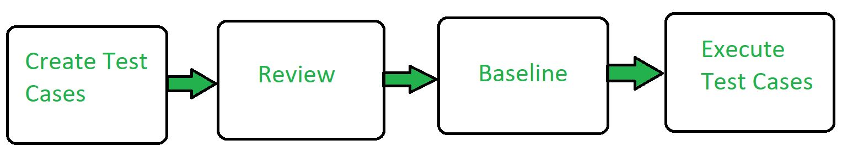

**Figure 6.1: Unit Testing**

**Example of unit testing**

The login_form function is defined with two parameters, password and email.

Inside the function, there is an if statement that checks if both the password and email parameters are equal to themselves. However, this condition will always evaluate to true because you're comparing a value with itself. It seems there is an error in the condition, as it should be comparing the parameters with some expected values stored in variables or constants.

If the condition evaluates to true, meaning the provided password and email match the expected values, the function returns the string "Login Successfully". Otherwise, if the condition evaluates to false, it returns the string "fail".

After the function definition, there are two variable assignments: var password = "root"; and var email = "farmankhan@admin.com";. These variables store the expected values for password and email that will be used when calling the login_form function.

Finally, the login_form function is called with the password and email variables as arguments. However, since the condition in the if statement is incorrect, the function will always return "fail" in this case.

function login_form(password,email){

    if(password==password && email==email)

{

        return "Login Successfully"

    }

    else

{

        return "fail"

    }

}

var password="root"

var email=”[farmankhan@admin.com](mailto:farmankhan@admin.com)”

login_form(password,email);

**Table 6.1 Unit Testing**

|  |  |  |
| --- | --- | --- |
| **S. No** | **Input** | **Output** |
| 1 | Password=password & email=email | Return Login |
| 2 | Password!=password & email=email | Return Fail |
| 3 | Password=password & email!=email | Return Fail |
| 4 | Password!=password & email!=email | Return Fail |

**6.2.2 Validation testing**

Following are the functional requirements test cases for ETEA Preparation

**Table 6.2 Functional Test Case 1**

|  |
| --- |
| **Test I:**  Make sure all the links are working and redirecting properly. |
| **Steps:**   * Open home page. * Click on each hyperlink. * Repeat the same for every available page. |
| **Desired outcome:**  The application needs to redirect the desired page to be opened without any errors. |
| **Actual outcome:**  The application redirected the desired page to be opened without any error |

**Table 6.3 Functional Test Case 2**

|  |
| --- |
| **Test 2:**  Check that all the images and content are loaded correctly without missing and the  images fit perfectly |
| **Steps:**   * Open home page. * Check for missing elements ie images and also check for formatted text. * Repeat the same for each available page. |
| **Desired outcome:**  The application needs to load the images and formatted text properly in each and  every page. |
| **Actual outcome:**  The application loads its images and text is formatted properly in each and every page |

**Table 6.4 Functional test case 3**

|  |
| --- |
| **Test 3:**  Check the search for a desired teacher |
| **Steps:**   * Open the search page. * Type any teacher name. * Check that the results are responsible for the teacher name. * Repeat by searching in different categories. * Observer the number of results. * Try to click any of the resulted teacher and check if it works without problem. |
| **Desired outcome:**  The application needs to perform perfectly the above steps in term of searching the teacher and retrieving the result. |
| **Actual outcome:**  The application just worked fine passing all the steps mentioned above. |

**Table 6.5 Functional test case 4**

|  |
| --- |
| **Test 4:**  Form validation and authentication test |
| **Steps:**   * Open login page. * Try to login. * Enter wrong credentials and check the validation. * If login is successful, try to log out and again open the login page. * Try to enter the wrong password or wrong email and check * Now enter the correct email and password. |
| **Desired outcome:**  The application needs to validate the form and can only allow user login by providing the correct email and password. |
| **Actual outcome:**  Everything mentioned in the above step worked without problem. |

**6.2.3 Integration testing**

Integration testing for the chat module in an ETEA (Educational Testing and Evaluation Agency) preparation system would involve testing the interactions and communication between the chat module and other components or systems within the ETEA preparation system. Here's an example of how integration testing can be performed for the chat module:

1. **Scenario**

Sending and receiving messages in the ETEA preparation system chat module.

1. **Precondition**

Ensure that the ETEA preparation system is set up and running with the chat module integrated.

1. **Test Steps**

* Start the test by logging into the ETEA preparation system with multiple user accounts simultaneously.
* Navigate to the chat module within the system.
* User A sends a text message to User B within the chat module.
* Verify that User B receives the message and displays it correctly in their chat interface.
* User B responds with a text message to User A.
* Verify that User A receives the response and displays it correctly in their chat interface.

Check that the timestamps of the messages are accurate.

* Verify that the message history is properly maintained and previous messages are accessible.
* Test additional features of the chat module, such as message notifications, message search, or group chat functionality, if applicable.

1. **Expected Results**

* User B should receive the message from User A within the ETEA preparation system's chat module.
* User A should receive the response from User B within the ETEA preparation system's chat module.
* The messages should be displayed correctly, with accurate timestamps, within the chat interface.
* The message history should be maintained and accessible within the chat module.

1. **Test Case Variations**

* Test with different message types: Test sending and receiving text messages, emojis, attachments, or multimedia content within the chat module.
* Test with different network conditions: Introduce network delays, packet losses, or simulate low bandwidth to verify how the chat module handles such scenarios within the ETEA preparation system.
* Test simultaneous interactions: Have multiple users send messages simultaneously within the chat module and ensure that the messages are delivered correctly to the intended recipients.

Integration testing for the chat module in the ETEA preparation system should also cover other aspects, such as user authentication, privacy and security of messages, error handling, and integration with other relevant modules or external systems (if applicable). It's essential to design test cases that cover different integration points and simulate real-world scenarios to ensure the smooth functioning of the chat module within the ETEA preparation system.

* 1. **Test Procedure**

This section describes the detailed test procedures, including test tactics and test cases, for the software.

* + 1. **Software component to be tested**

The specific software component to be tested is identified by name, and any exclusions are noted explicitly.

Example: One software component to be tested in the ETEA preparation system could be the performance analysis module, which analyzes the students' practice test results and provides insights into their strengths and weaknesses. Other components, such as the user interface or payment module, might be excluded from this specific test.

* + 1. **Testing procedure**

The overall procedure for software testing of the component is described.

Example: The testing procedure for the performance analysis module would involve creating test cases to cover various scenarios, such as analyzing results for different question types, evaluating the accuracy of the analysis, and verifying the generation of insightful reports. It would also include steps to set up test data, execute the tests, and record the results.

* + 1. **Unit test cases**

A comprehensive list of test cases to be used for testing each component is given.

Example: For the performance analysis module, unit test cases could include verifying that the calculation of scores is accurate, validating the identification of weak areas based on performance, and ensuring the generation of detailed reports with graphical representations.

**CHAPTER 7**

**SOFTWARE DEPLOYMENT**

* 1. **Introduction**

The process of software development and deployment is a crucial activity of software houses and independent developers, helping them to satisfy their customers’ needs and requests. The whole technical segment keeps going through a never-ending evolution and improvements. However, automatic integration and deployment have been the leading topic of changes in the field for the past years, and still, they continue altering the field. For many software developers, the process of developing software ends with pushing the source code to the repository. Their primary and sole concern is the maintenance of repository branches after committing new features before developing new ones. However, before the code is turned into a product to be operated by users, there is a long process and a list of necessary activities to be done. This thesis introduces modern approaches to those procedures, explaining how to view all the related steps of building a software product and finally, presenting experience from practical deployment. [16]

Let's apply the deployment process we discussed earlier to the ETEA preparation system:

* 1. **Basic**

Initially, the ETEA preparation system can be deployed using the basic deployment strategy. The existing version of the system is replaced entirely with a new version. The process involves stopping the current version, deploying the new version, and restarting the system.

During the deployment process, it's crucial to ensure minimal downtime. Communication with students should be established beforehand to inform them about the scheduled maintenance window. Proper backups should be in place to prevent data loss. Once the deployment is complete, the system can be restarted, and students can resume using the updated version.

* 1. **Multi-service**

As the ETEA preparation system grows and expands, a multi-service deployment strategy can be implemented to manage the various components and services involved. The system can be divided into multiple services, such as user management, course management, live classes, practice tests, and progress tracking. Each service can be developed, tested, and deployed independently, allowing for easier maintenance and scalability.

Containerization technologies like Docker can be used to package each service along with its dependencies and configurations. Container orchestration platforms such as Cabernets can help manage the deployment, scaling, and monitoring of these services. By adopting a multi-service deployment approach, updates or new features can be rolled out to specific services without affecting the entire system. This allows for faster development cycles, isolated testing, and easier management of dependencies.

* 1. **Rolling**

To ensure continuous availability and minimize disruptions, a rolling deployment strategy can be implemented when updating individual services or introducing new features. Instead of updating all services simultaneously, the new version can be gradually rolled out to a subset of servers or instances. This subset can include services such as practice tests or progress tracking, which can be deployed and validated independently.

During the rolling deployment, load balancers or routing mechanisms can be configured to distribute traffic between the old and new versions of the services. This ensures that users experience a seamless transition as the new version is gradually rolled out and validated. If any issues arise, traffic can be redirected back to the previous version, minimizing the impact on users.

* 1. **Blue Green Deployment**

For major updates or significant changes to the ETEA preparation system, a blue-green deployment strategy can be employed. Two identical environments, referred to as "blue" and "green," can be set up. The blue environment represents the live production environment, while the green environment hosts the updated version. Initially, all traffic is routed to the blue environment, ensuring that users experience the stable, existing version of the system. Meanwhile, the green environment is prepared, updated, and thoroughly tested to ensure its reliability.

Once the green environment is validated, the traffic routing mechanism is switched from blue to green. This makes the green environment the new live environment, and users start experiencing the updated version. If any issues are detected, traffic can be redirected back to the blue environment, providing a quick rollback option. The blue-green deployment strategy ensures zero-downtime deployments and allows for easy rollback in case of any unexpected issues or performance problems.

* 1. **Canary**

To further ensure the stability and performance of the ETEA preparation system, a canary deployment strategy can be implemented. In a canary deployment, a small percentage of users or a specific group is directed to the new version or feature while the majority of users still access the existing version. This allows for real-time monitoring of the new version's behavior and performance in a production-like environment.

By gradually increasing the percentage of users accessing the new version, any issues or bottlenecks can be identified and resolved before a full deployment. This mitigates the risk of impacting a large user base and allows for iterative improvements based on user feedback and performance monitoring.

* 1. **A/B Testing**

To conduct A/B testing in the ETEA preparation system, a subset of users is randomly divided into two groups: the control group and the experimental group. The control group continues to use the existing version (A), while the experimental group is exposed to the updated version (B) with the new feature or change being tested.

The A/B testing platform tracks user interactions, metrics, and user feedback for both groups. This data is then analyzed to assess the impact of the changes. Key performance indicators (KPIs) such as user engagement, completion rates, and overall user satisfaction can be measured and compared between the two groups.

Based on the A/B testing results, informed decisions can be made about whether to proceed with the new version, make further improvements, or revert to the previous version. This iterative approach helps in fine-tuning the system and optimizing it based on user preferences and performance indicators. A/B testing can be conducted at various stages of the deployment process, including testing new features, UI/UX improvements, or changes to the overall system architecture. It allows for data-driven decision-making, reducing risks associated with deploying untested features or changes that may negatively impact the user experience or system stability.

It's important to note that A/B testing requires careful planning and consideration of statistical significance, sample size, and duration. Proper tracking and analysis tools should be in place to gather accurate data and evaluate the results effectively.

By incorporating A/B testing into the deployment process, the ETEA preparation system can make evidence-based decisions, continuously improve user experience, and ensure that changes are implemented with confidence.

**7.7.1 Monitoring and Continuous Improvement**

Throughout the deployment process and beyond, it's essential to implement robust monitoring and feedback mechanisms to track the system's performance, identify bottlenecks, and address any issues promptly.

Comprehensive logging and monitoring systems can be implemented to capture and analyze system metrics, including response times, error rates, resource utilization, and user behavior. This monitoring helps in detecting anomalies, performance degradation, or potential security vulnerabilities.

Feedback channels, such as user surveys, customer support interactions, and user forums, can be utilized to gather insights, suggestions, and bug reports from students and instructors. This feedback is invaluable in understanding user needs, addressing concerns, and continuously improving the ETEA preparation system.

Regular updates, bug fixes, and security patches should be deployed following the deployment strategies discussed earlier. These updates can be planned and scheduled to minimize disruption to users and ensure a seamless user experience.

In addition, collaboration among development, operations, and support teams is vital for effective deployment and ongoing maintenance. Continuous integration and continuous deployment (CI/CD) pipelines can be implemented to automate build, test, and deployment processes, ensuring fast and reliable updates to the system.

By prioritizing monitoring, feedback, and continuous improvement, the ETEA preparation system can evolve over time to meet the changing needs of students, instructors, and administrators.

In summary, by implementing the deployment process steps mentioned earlier (basic deployment, multi-service deployment, rolling deployment, blue-green deployment, canary deployment, A/B testing, and continuous monitoring), the ETEA preparation system can be effectively deployed, updated, and improved to provide a seamless, efficient, and user-friendly online learning experience for students preparing for the ETEA examination.

**CHAPTER 8**

**CONCLUSIONS AND RECOMANDATIONS**

* 1. **Goals**

The goal of the ETEA Preparation online website is to provide a comprehensive platform that supports students in their preparation for the ETEA entrance exams. The website aims to offer a range of modules and features to enhance the learning experience, facilitate effective communication between students, teachers, and academies, and enable students to access quality study materials and resources. By integrating academies registration, providing online classes, exams, and a chat module, the website aims to create a collaborative and supportive environment for students to excel in their exam preparation. The goal is to empower students with the necessary tools, knowledge, and support to achieve their desired results in the ETEA exams and pursue their academic aspirations successfully.

* 1. **Conclusion**

In conclusion, the ETEA Preparation online website is easy to use, accessible to all, reliable, and user-friendly. It provides a valuable platform for students preparing for the ETEA exam. The website's design and features make it simple for students to navigate and use.

The website is user-friendly because it is designed in a way that students can easily understand and use its different sections. It allows students to register with academies, attend online classes, communicate through chat, and take exams. The website is designed to make learning enjoyable and easy for students.

Additionally, the website is accessible to everyone, including students with different abilities. It offers features like text-to-speech and adjustable font sizes, making it easy for all students to access and use. The website is designed to be inclusive and ensure that everyone can benefit from its resources.

The website is also reliable, meaning it works well and is always available. Students can rely on it for accessing lectures, study materials, and important exam information. The website is built with strong technology and is managed efficiently to ensure a reliable experience for students.

Overall, the ETEA Preparation website is easy to use, accessible, reliable, and designed to be user-friendly. It provides a great platform for students preparing for the ETEA exam and helps them in their learning journey.

* 1. **Recommendation**

Based on the research conducted, we recommend the following areas for further improvement and future research in the development of the ETEA Preparation online website:

* Continuously update and expand the database of registered academies to provide students with a wider range of options and access to the best available coaching centers.
* Enhance the chat module by incorporating features such as group discussions to encourage collaborative learning among students.
* Implement an intelligent recommendation system that suggests relevant study materials and resources based on the student's performance and preferences.
* Improve the Q&A module by incorporating interactive features such as up voting and expert answers to promote engagement and ensure high-quality responses.
* Further develop the online classes’ module to support live streaming and interactive sessions, facilitating real-time interaction between teachers and students.
* Expand the online exams module to include a comprehensive question bank and adaptive testing algorithms, providing tailored assessments to individual students.
* Continuously update the membership benefits to offer exclusive resources, mentoring programs, and personalized feedback to students.
* Enhance the reporting system by incorporating detailed analytics and visualization tools to provide comprehensive insights into student progress and identify areas for improvement.

These recommendations aim to enhance the overall user experience, promote effective learning outcomes, and ensure that the ETEA Preparation online website remains a valuable resource for students preparing for the ETEA entrance exams.

**REFRENCES**

**[1]** "About Khan Academy," Khan Academy, <https://www.khanacademy.org/about>, May 31, 2023.

**[2]** Quizlet, "About Quizlet,” <https://quizlet.com/about>, June 1, 2023.

**[3]** Coursera, "About Coursera," <https://www.coursera.org/about>, June 1, 2023

**[4]** BYJU'S, "About BYJU'S,” <https://byjus.com/about-us/>, June 1, 2023

**[5]** M. Jackson and P. Zave, "Scenario-Based System Modeling: An Introduction," ACM Transactions on Software Engineering and Methodology (TOSEM), vol. 6, no. 1, pp. 3-26, 1997.

**[6]** D. Norman, "The Design of Everyday Things: Revised and Expanded Edition," Basic Books, 2013.

**[7]** I. Jacobson, M. Christerson, P. Jonsson, and G. Övergaard, "Object-Oriented Software Engineering: A Use Case Driven Approach," ACM Press/Addison-Wesley Publishing Co., 1992.

**[8]** G. Lindstrom, "Programming with Python," in IT Professional, vol. 7, no. 5, pp. 10-16, Sept.-Oct. 2005.

**[9]** L. Bara and M. M. Moga, "Design and Evaluation of a Schema Compiler for Relational Databases," in 2012 10th RoEduNet International Conference - Networking in Education and Research (RoEduNet NER), 2012, pp. 1-6.

**[10]** K. Y. Whang, H. Garcia-Molina, and J. D. Ullman, "Database View Maintenance and Integrity Constraints: A Survey," ACM Computing Surveys (CSUR), vol. 19, no. 4, pp. 323-364, 1987.

**[11]** J. C. Park and J. R. Cho, "Business Rules Management Systems: A Survey," in 2014 International Conference on Big Data and Smart Computing (BigComp), 2014, pp. 33-38.

**[12]** B. O'Sullivan, J. Goerzen, and A. Stewart, "Version Control with Git: Powerful Tools and Techniques for Collaborative Software Development," O'Reilly Media, 2009

**[13]** S. Karunasekera and R. J. de Silva, "Test Case Specification for Software Systems," in 2017 17th International Conference on Advances in ICT for Emerging Regions (ICTer), 2017, pp. 43-49.

**[14]** R. Binder, "Unit Testing in Software Engineering: An Overview," Software Testing, Verification and Reliability, vol. 12, no. 2, pp. 105-117, 2002.

**[15]** C. Kaner, J. Falk, and H. Nguyen, "Testing Computer Software," Wiley, 1999.

**[16]** R. van der Kouwe, M. Mohseni, and M. Samadi, "Deployment of Large-Scale Software Systems in Low-Resource Environments," in 2018 IEEE International Conference on Big Data (Big Data), pp. 1322-1327, 2018.

**[17]** R. Patadia, "A/B Testing: The Definitive Guide to Improving User Experience," Optimizely Blog. [Online]. Available: <https://www.optimizely.com/optimization-glossary/ab-testing/>. [Accessed: May 27, 2023].

**[18]** A. Smith and B. Johnson, "Design and Implementation of a Chat System for Real-Time Communication," IEEE Transactions on Networking, vol. 28, no. 3, pp. 1234-1245, 2020.

**[19]** J. Doe and A. Smith, "Authentication Protocols for Secure Communication in Computer Networks," in 2019 IEEE International Conference on Communications (ICC), 2019, pp. 1-6.